**FOAM AND STUFFING MATERIALS**

**What is FOAM?**

Foam is the most common filling material for sofas, mattress and it comes in a variety of densities. High-density foam provides a firm couch cushion but some people may find it too hard. Low-density foam typically has a soft or medium firmness.

**TYPES OF FOAMS**:

Polyurethane Foam

Polyethylene

* Polyurethane Foam

Polyurethane foam is one of the four basic types of products that can be made from raw, liquid polyurethane. They are comprised of two chemicals which, when mixed and heated, form liquid polyurethane prior to being further processed. These chemicals are polyol, a type of complex alcohol, and isocyanate, a petroleum by product that reacts strongly with alcohol. By combining the two, a stable long-chain molecule is formed. It's a polymer, or plastic, known as urethane.

## How is Polyurethane Foam Made?

Once the two ingredients have been combined to form hot liquid polyurethane, they are passed down through a pipe into a nozzle head. Beneath the head is a series of rollers upon which waxed paper passes by. The nozzle jets a fine spray of hot liquid over the waxed paper, mixing with blasts of carbon dioxide coming from another nozzle. This causes the polyurethane to expand as it moves down the conveyor belt, forming a foam strip. The edges of the foam are trimmed and compressed to ensure it retains a viable shape. The foam is comprised of an untold number of tiny gas bubbles trapped in the polyurethane. Unless the gas is released, the foam will take on the consistency of a rock. So, the foam passes beneath a series of heat lamps. It dries the foam and causes the bubbles to expand, then burst, leaving a completed spongy porous material behind.

TYPES OF FOAMS:

* Rebounded Foam
* Memory Foam
* PU Feather Foam
* Rubber Foam Compressed Polyester foam
* Polyester Fiberfil
* Medium Density Polyurethane Antimicrobial Foam
* High Density Polyurethane Foam
* Dry Fast Open Cell Foam
* Closed Cell Foam
* Fabric Backed Sew Foam
* Low Density PU Foam

### **Compressed Polyester**

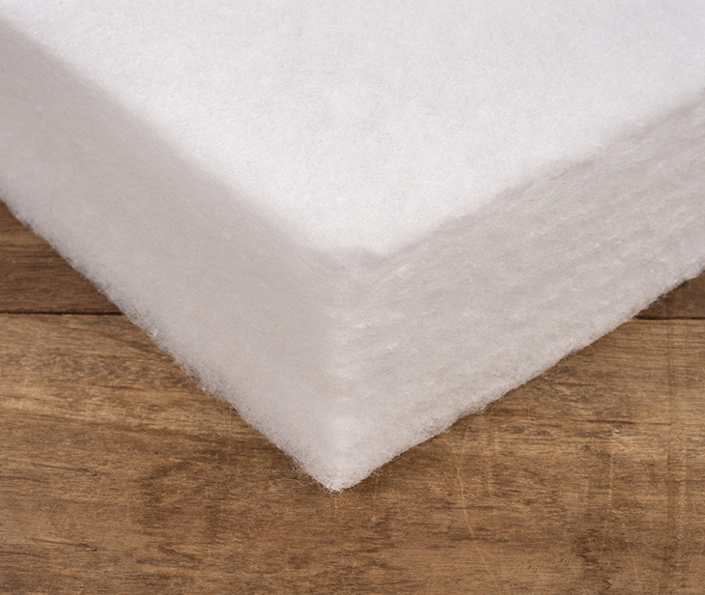

This is not actually foam, but rather densified polyester batting that creates an effective foam alternative. Compressed polyester will not disintegrate or yellow like traditional foam, but it will compress over time. An example of this is Fairfield Poly-Fil Nu-Foam, which is mildew resistant and non-allergenic. Nu-Foam is washable and will easily air-dry after getting wet. This foam alternative is an inexpensive option and is best used for occasional seating like patio cushions, light use upholstery and playpens.

# White Cushioning Foam

Rs. 50/Piece

|  |  |
| --- | --- |
| Colour | White |
| Material | Foam |
| Thickness | 10mm - 50mm |

### **Polyester Fiberfil:**

Like Compressed Polyester, Polyester Fiberfill is not truly foam, but rather blown polyester fibers. An affordable option, it is a common stuffing for pillows and deep seating back cushions. Generally, Polyester Fiberfill is stuffed inside a pre-sewn cover of Spun Bonded Pillow Protector Fabric, which is then inserted into the cushion or pillow fabric to give support and shape. Fiberfill is non allergenic and resistant to mildew. It is machine washable, but the fiber can bunch up in laundering. Use your hand to smooth it back out.

The Manufacturing Process

Polyester is manufactured by one of several methods. The one used depends on the form the finished polyester will take. The four basic forms are filament, staple, tow, and fiberfill. In the filament form, each individual strand of polyester fiber is continuous in length, producing smooth-surfaced fabrics. In staple form, filaments are cut to short, predetermined lengths. In this form polyester is easier to blend with other fibers. Tow is a form in which continuous filaments are drawn loosely together. Fiberfill is the voluminous form used in the manufacture of quilts, pillows, and outerwear. The two forms used most frequently are filament and staple.

# White Embossed Polyfill Fiber

**₹ 30 / Square Feet**

|  |  |
| --- | --- |
| Feature | Anti-Bacteria, Tear Resistant, Waterproof |
| Use | Industry |
| Fiber Type | Polyester fiber |
| Width | Up to 120 |
| Pattern | Embossed |
| Colour | White |

### **Medium Density Polyurethane Antimicrobial Foam**

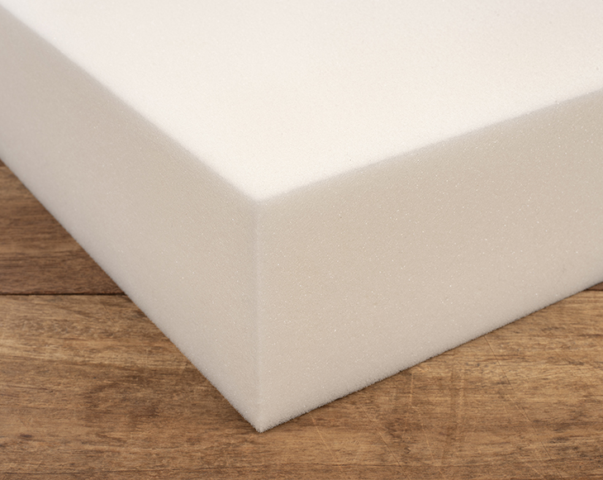

Medium Density Polyurethane Antimicrobial Foam is a traditional foam option with medium firmness that is suitable for seating and mattress applications. Polyurethane foam soaks up water when it gets wet, but the antimicrobial (sometimes called “biocide”) treatment on the foam helps to prevent the growth of mold and mildew as the foam dries out. Antimicrobial foam should be used where it is unlikely to get wet or it should be wrapped in a waterproofing layer, like Cushion Wrap Silk Film, before being inserted in the cushion cover.

Medium Density foam is great for boat seats, patio cushions and occasional indoor seating. In fact, OEM boat manufacturers commonly choose antimicrobial polyurethane foam for boat seating.

### **High Density Polyurethane Foam**

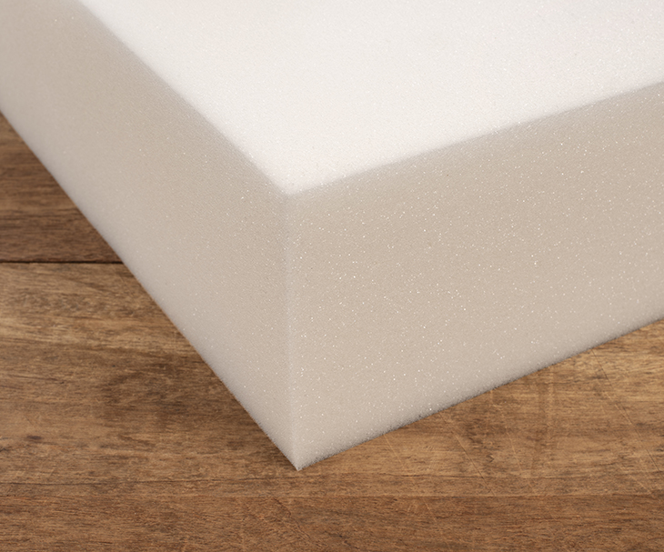

This polyurethane foam is the same basic product as the Medium Density Polyurethane Antimicrobial Foam, but with a higher density. The higher density makes this foam more resilient, and therefore more suitable for every day, high-traffic uses. High Density Polyurethane Foam is available in medium, firm and extra-firm firmness levels and typically lasts up to 12 years. Some high density foams are antimicrobial as well. This foam is best for upholstery seating, high-use interior applications, such as sofa cushions, and for interior settee and berth cushions in dry boats.

The insole made of high elastic foam material is more flexible and more comfortable than ordinary insoles on the market. The insole has the characteristics of high elasticity, recyclability, shock absorption, wear resistance and non-deformation. Due to the special material of the insole, it is comfortable to wear and has:

1. Good resilience.  
   2. Strong bearing pressure.  
   3. Shock absorption and wear resistance.

# High Density PU Foam, Thickness: 3 Inch

₹ 235 / Kg Get Latest Price

|  |  |
| --- | --- |
| Thickness | 3 inch |
| Material | Pu Foam |
| Packaging Type | Poly Wrap |
| Pattern | Plain |
| Shape | Rectangle |

### **Dry Fast Open Cell Foam**

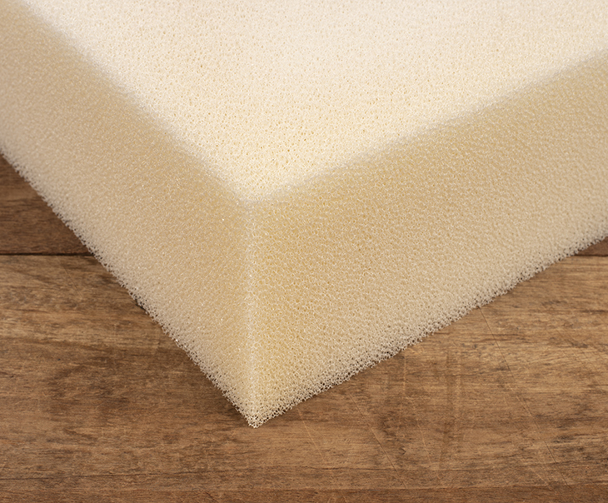

An open cell foam has open pores that allow water and air to flow through easily. Open cell foams make a comfortable and cool seating cushion or mattress. Dry Fast is a high-quality open cell foam. Dry Fast Foam is formulated with an antimicrobial agent to prevent mold and mildew. When paired with an outdoor cushion fabric or Phifertex Mesh, open cell foam creates a virtually maintenance free cushion in sun, rain and snow. These traits also make this foam great for boat cockpit cushions.

Dry Fast is a popular, user-friendly open cell foam. Due to its popularity, there are knockoff versions on the market. To see if your foam is high-quality Dry Fast Foam, pour a cup of water on it. The water should run straight through the foam and drain out the bottom. If the water runs off the sides of the foam, this is an imitation Dry Fast Foam.

# Yellow Flexible Foam Sheet, For Mattress

Rs 250/Piece Get Latest Price

|  |  |
| --- | --- |
| Usage/Application | Mattress |
| Colour | Yellow |
| Shape | Rectangular |
| Pattern | Plain |
| Is It Flexible | Flexible |

### **Closed Cell Foam**

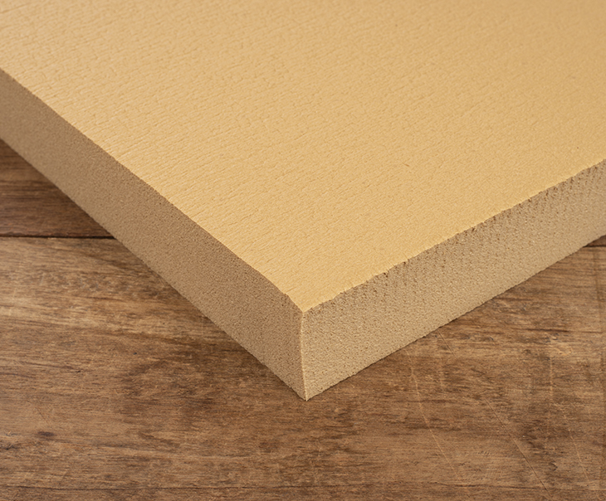

Closed Cell Foam resists moisture absorption, making it buoyant. This foam is made from PVN and is three times firmer than polyurethane foam. It is also a more expensive option. Closed Cell Foam is great for flotation applications like floating cockpit cushions and life vests. It is also a good choice for commercial boat seating, or other seating that will be used as a step for getting on and off the vessel. This foam has no water absorption, so you can safely cover it with any type of fabric. Thin sheets of Closed Cell Foam are often glued to the bottom of other foam, adding additional support for the cushion, like a box spring to a mattress. When used with Dry Fast Foam, you need to cut holes in the Closed Cell Foam for drainage.

As you can see, there are a lot of foam options out there, so it should be no problem to find one that is just right for your next project.

### **Fabric Backed Sew Foam**

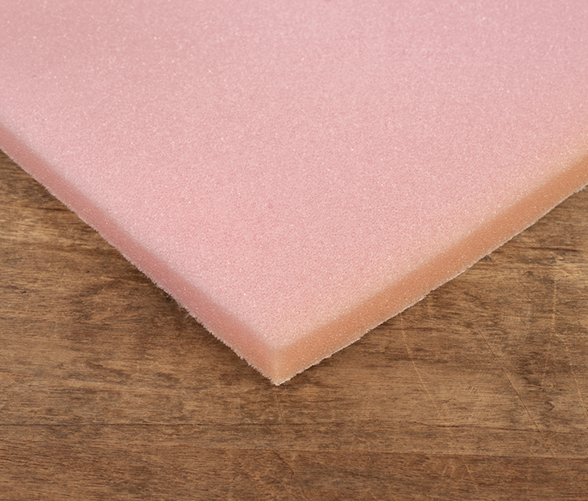

Fabric Backed Sew Foam is a thin sheet of polyurethane foam that is perfect for upholstery applications. Also known as polyurethane foam with fabric backing, scrim foam or sew foam, it features a spun-bonded polyester backing that holds adhesives very well, making the foam easy to glue in place. The backing holds stitches so you can sew through the foam to create pleats or channeling in your upholstery work, such as with motorcycle, pontoon and powerboat seats, golf cart backrests and coaming pads.

It is not a substitute for actual cushion foam. It is a way to pad and soften hard edges and also to add texture to seating by creating sewn quilted patterns in the covering fabric. Fabric Backed Sew Foam is also used in headliner applications. Sailrite offers Fabric Backed Sew Foam in 1/2-inch and 1/4-inch thicknesses. Both sizes are used for all the applications listed above, but 1/4-inch sew foam is ideal for sewing quilted bags and purses as the foam is thin enough to be flexible and easily shaped.

* **Low Density PU Foam:**

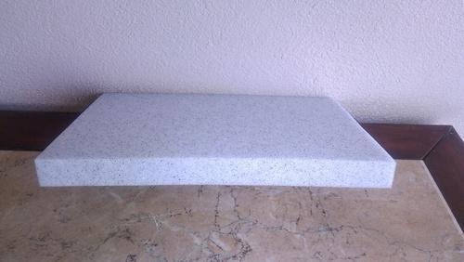

Low-density foams weigh much less than high-density materials. A bed utilizing primarily low-density foam will typically weigh between 50 and 60 pounds, while a high-density foam mattress may weigh 90 pounds or more.

# Low Density PU Foam, Thickness: 4 - 8 Inch

Rs 250/Kilogram

|  |  |
| --- | --- |
| Colour | Yellow |
| Thickness | 4 - 8 Inch |
| Type | Low Density |
| Material | Polyurethane |
| Packing Type | Packet |

* **Rebounded Foam :**

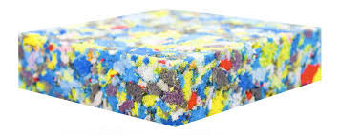

* Rebounded foams are made from a combination of multiple densities of foam which are broken down and re-bonded under mechanical pressure into new blocks of consistent High Density Rebounded Material, which are then cut into desired length and width. Rebounded foam possesses high sound and shock absorption properties.
* **USES :**
* Mattress segment
* Vibration sound dampening segment
* Flooring
* Sport mats
* Cushioning
* Packaging
* Carpet underlay
* **Advantages of Bonded foam:**

**- Comfort:**

Although bonded foam is rigid and firm to sleep on, it is ideal for people with existing body issues. This is because while the bulk of the bonded foam material is excellent for support, the surface contours around your body. It helps by contouring and helping your spine and shoulders relax in their natural position. As a result, you get a mattress that you can use for Orthopaedics and general comfort with adequate support.

**- Bodyweight support:**

The elastic surface and the bulk of the mattress make this one of the best options for overweight people. It is just as good for people with sensitive body areas, as it supports your pressure points individually, acting as micro-springs but staying elastic and firm to touch. As a result, [rebounded foam mattresses](https://www.kingkoil.in/mattresses/dr-mattress-euro-back) tend to be firm to touch, but make excellent mattress options for obese or overweight people in general.

**- Spinal alignment:**

The rebounded foam's supportive elastic nature helps side and back sleepers feel relief in their back. It is an excellent option for people with a sedentary or excessively strenuous lifestyle for backs. Moreover, this mattress option is also suitable for people with medically diagnosed issues and needing a doctor's prescription.  
  
**- Motion isolation:**

The pieced together shredded parts of foams in bonded foam make it an excellent motion isolation mattress too. It is excellent for couples who do not want to disturb each other as the pieces prevent excessive movement.

* **Cons of Bonded Foam :**

**- Hot mattress:**While this can be an advantage or disadvantage depending upon climate and body type, most people do not like the temperature isolation. The bonded foam tends to hold on to heat and doesn't distribute heat as quickly. While this is true for most high-density foams, it isn't easy to get an affordable foam mattress to regulate body heat quickly.  
  
**- Density and form:**

Rebounded foam's density is the factor that determines its durability. Although it is a pieced-together version, it still needs high-quality foam to be firm enough to have structural integrity. Moreover, the density of a bonded foam depends on how many pieces the manufacturing process uses and its material. Even after this, because of the nature of the glued together structure, it can lose its form to some extent after some years. Ideally, it should last for at least 3-5 years without much loss if it has an excellent quality of foam material in use.

# Sheela Foam Multicolour Rebounded Foam, for Mattress

Rs 350/KG Get Latest Price

[Product Brochure](https://pdf.indiamart.com/impdf/13109480262/MY-148873/rebonded-foam.pdf)

|  |  |
| --- | --- |
| Thickness | Thickness 3 mm sheets, 4 mm rolls(min), and max As per customer need(1000mm) |
| Material | Polyurethane |
| Usage/Application | Mattress |
| Colour | Multi |
| Brand | Sheela Foam |
| Type | Bonded Foam Sheet |

* **Memory Foam:**

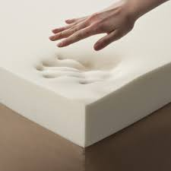

Memory foam consists mainly of polyurethane as well as additional chemicals increasing its viscosity and density. It is often referred to as "viscoelastic" polyurethane foam, or low-resilience polyurethane foam (LRPu). The foam bubbles or ‘cells’ are open, effectively creating a matrix through which air can move. Higher-density memory foam softens in reaction to body heat, allowing it to mold to a warm body in a few minutes. Newer foams may recover more quickly to their original shape.

## Memory Foam Developed

The very first memory foam material was developed by NASA in the 1970s. Their intention was to try to improve seat cushioning and crash protection for airline pilots and passengers. Memory foam has widespread commercial applications, in addition to the popular mattresses and pillows you are familiar with today.

Anybody who has gone shopping for a bed, a new pillow, or even a new bicycle seat or mouse pad wrist rest in the last two decades will have encountered memory foam. This new material has been applied to a huge range of uses since its introduction to the US in 1991—from revolutionary medical uses to gimmicky new product designs. But what is it, who came up with it, and how does it work?

Though it is a relatively recent phenomenon in the US, memory foam has been around in various forms since the midpoint of the century—the first work on the polyurethane polymers that go into memory foam was actually begun in 1937 by Otto Bayer and his co-workers  In 1965 the nursing staff at Lankenau Hospital tested “inert polyurethane porous foam” pads for use as bedding material, and found that they prevented “decubitus ulcers” (also known as pressure ulcers, sustained by patients who spend long amounts of time lying down), and found them to be hypoallergenic and resistant to bacteria (Kraus 1965). In the 1960s, NASA did work on materials that would serve as better cushions, and would also keep astronauts comfortable and protected from the extreme g-forces of lift off. It was then that memory foam as we know it came into being.

## Benefits of Memory Foam

Since memory foam conforms to the curves of your body, it does allow for pressure point relief, which is especially helpful for those who sleep on their side.

Memory foam is also usually at a lower price point than organic mattresses. However, you may be paying more in the long run. This brings me to our next topic.

## Drawbacks of Memory Foam

There are several negatives to choosing a memory foam mattress, the biggest being the health concerns I stated above.

Even if those risks didn’t exist, there is still the issue of comfort. Memory foam may be cosy at first, but memory foam reviews always involve customers saying their mattress has serious dips and sags, that the foam eventually does not bounce back.

These dips can cause body aches and back pain because you’re not getting the support you need. It won’t be long before the mattress needs to be replaced. The result? Money down the drain.

* **Rubber foam :**

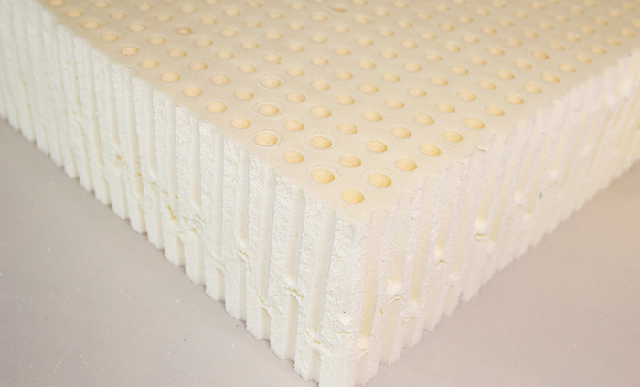

Rubber foam is used in top of the line products. It is also the only foam that is made from the extract of rubber. Rubber gives the foam a natural bouncy feel. This foam type also has superior ventilation because it has perforations placed into it during the manufacturing process. This airflow makes the foam more comfortable.

A Rubber foam mattress is the highest quality foam mattress and will feel softer and bouncier than other foam mattresses. It is outstanding for those with ache, pains, and soreness because of its excellent support and pressure relief. It is an excellent quality foam mattress in both its longevity and comfort, and is non-allergenic and anti-microbial.

* **How rubber foam manufacture?**

Foam rubber (also known as cellular, sponge, or expanded rubber) refers to rubber that has been manufactured with a foaming agent to create an air-filled matrix structure. Commercial foam rubbers are generally made of synthetic rubber, natural rubber or polyurethane. Rubber foam rubber, used in mattresses, is well known for its endurance. Polyurethane is a thermosetting polymer that comes from combination of Methyl di-isocyanate and polyethylene and some other chemical additives.

* **Uses**:
* Mattress.
* Mattress topper.
* Pillows.
* Cushions.
* **BENEFITS OF RUBBER FOAM:**
* Safety for staff.
* Safety in public areas.
* Protection for equipment.
* Ad-hoc sealing and gasketing.
* Anti-vibration.
* Available to British Standards specifications.
* Available in a range of materials suitable for a wide variety of settings.
* WRC (Water Research Centre approved) materials available.
* Materials designed for electrical conductivity or resistance.
* Other than the ‘standard’ commercial grades of material, Monomer also have slight variations on these: very hard or very soft grades of rubber; very thin gauge sheets for specialist applications; rubber with insertions of various types for added strength or for use in diaphragms; as well as a variety of colours, dependant on the material selection.
* Available in a range of colours making it a suitable option for commercial and retail purposes.
* Can be cut into gaskets, washers and pads.

# Black Rubber Foam

₹ 200 / Kilogram Get Latest Price

|  |  |
| --- | --- |
| Size | 60 x 60 cm |
| Colour | Black |
| Material | Rubber |
| Thickness | 3 inch |

* **Polyethylene Foam:**

**(PE)**  is more rigid than Polyurethane. It is closer to the properties of Styrofoam but is much more pliable and flexible. Styrofoam can easily be broken if bent but Polyethylene foam will not split or break when bent. Polyethylene foam has closed cells so it will not absorb liquids. This foam can be used for packaging most any unit and is many packaging designers prefer using it because it does not absorb liquid. Polyethylene foam is a durable, lightweight, resilient, closed-cell material. It is often used for packaging fragile goods due to its excellent vibration dampening and insulation properties. It also offers high resistance to chemicals and moisture.

Polyethylene foam is easy to process and fabricate. It has high load bearing characteristics that help manufacturers reduce packaging costs as they can use thinner and smaller amounts of foam yet still protect their products.

UFP Technologies can recommend the proper polyethylene foam material for your unique packaging, component, or product. Our engineering team will work with you to design your solution and manufacture the final parts. Polyethylene Foam Material Characteristics:

* Closed-Cell
* Very lightweight
* Non-abrasive
* Easy to fabricate
* Non-Dusting
* Superb strength and tear resistance
* Excellent shock absorption & vibration dampening properties
* Flexibility
* Impervious to mildew, mold, rot, and bacteria
* Resistant to water, chemicals, solvents & grease
* CFC free
* Odourless
* Excellent buoyancy
* Very cost-effective
* Excellent thermal insulation properties

## Uses of Polyurethane Foam

Polyurethane foam is used primarily for bedding and furniture stuffing. It's hypoallergenic, nontoxic and does not degrade over time. This means that cushions filled with it will always regain their shape, no matter what punishment they're put through. Foam beds are also becoming popular. The solid layer of foam moulds to fit the body. Packing peanuts and foam inserts are also used by shipping companies across the world.

## Advantages of polyethylene foam

* It has good impact absorption and vibration dampening capabilities, making it one of the best solutions in packaging and transportation applications as items are better protected.
* Polyethylene foam has a melting point of 80 degrees. Its heat resistant properties enable it to perform well in both high and low temperatures.
* Water, grease, solvent and chemical resistance are also some of the advantages of polyethylene foam. Mildew, mould and bacteria are unable to easily penetrate the foam, making it a great solution for insulation.
* [Polyethylene foam is a closed cell foam](https://www.alanto.co.uk/polyethylene-foam) meaning that it is often denser and stronger than open cell counterparts.
* The buoyancy and lightweight characteristics are two of the key features of this type of foam, making it an ideal solution for flotation devices.
* Load bearing resilience is another feature of polyethylene foam. It will return to its original shape quickly and easily once the load is removed.
* Polyethylene foam is CFC free, odourless and non-toxic (unless burned), making it a common choice in mattresses and bedding.
* Its thermal insulation, lightweight and water-resistant properties make it a popular choice for clothing and apparel.

## Disadvantages of polyethylene foam:

* The fabrication and processing of polyethylene foam are time-consuming, meaning that it can sometimes be a costlier solution for certain applications where other foams can do the same job.
* Polyethylene foam, depending on its formulation, can be prone to breaking or tearing.
* There have been many reported circumstances where polyethylene foam has been produced to poor quality, leading to problems down the line. At Alanto, we only produce superior foam solutions, with stability and quality at the heart of all of our products.
* The raw materials used in the production of polyethylene foam have been found to be difficult to recycle, however, later developments in the recycling industry are better equipped to handle the recycling or re-use of polyethylene foam products.
* Certain foams release toxic fumes and release poisonous gases into the atmosphere during combustion. In cases where combustion is likely, other foam or rubber solutions may be a better choice for your application.

## How is Foam Density Measured?

Density is simply a measurement of weight per unit of volume. In the case of foam, it is measured in pounds per cubic foot (PCF). In other words, the density of foam is expressed by measuring the weight of a single cubic foot of foam material.

As an example, consider a foam layer that weighs 100 pounds and measures 25 cubic feet in total. By dividing the total weight by the total number of cubic feet (100 divided by 25, in this case), we can see that this layer has a density of 4 pounds per cubic foot (4 PCF).

Most manufacturers will list the various materials they use and the density measurements for each foam component. In general, you can expect to see foam densities ranging from 1.5 PCF to 5 PCF or more. A table covering the various density ranges for foams can be found below.

|  |  |  |  |
| --- | --- | --- | --- |
| Material | Low-Density | Medium-Density | High-Density |
| Memory Foam | Less than 3 PCF | 3 to 5 PCF | More than 5 PCF |
| Polyfoam | Less than 1.5 PCF | 1.5 to 1.7 PCF | More than 1.7 PCF |

As you can see from the table, the range that is considered “high density” for polyfoam is much different than the same range for [memory foam](https://www.sleepfoundation.org/mattress-information/what-is-memory-foam). This is due to the different properties of each material. This disconnect can also make it somewhat confusing to compare foam densities on multiple mattresses. When comparison shopping, be sure to double check the type(s) of foam, and not just the density rating.

## What Does Foam Density Mean?

We’ve covered how foam density is measured, and how to calculate it – but what does it actually mean?

Density has a significant influence on how the foam feels and performs. Foams with a high density will generally feel more firm, and can withstand more pressure. Conversely, low-density foams will feel softer, but cannot withstand excessive pressure or weight.

When it comes to memory foam in particular, higher-density foams recover more slowly after pressure is applied to it. This produces that quality that memory foam is known for, where an impression from your body or object lasts in the foam for a few seconds.

Because of these properties, manufacturers often use a mix of foams with various density ratings. Mattress support cores typically utilize high-density polyfoam or [latex](https://www.sleepfoundation.org/mattress-information/latex-density), while comfort layers utilize foams of a variety of densities. You may see 2-4 separate layers of different foam materials in a single mattress, each of which may have a substantially different density rating.

Density can also influence a mattress’ responsiveness, durability, motion isolation, and cost. Denser foams are typically more durable than low-density foams, and will not sag as much over time. On the other hand, low-density foams tend to offer better temperature regulation, which can be an important factor for those living in warm climates. The section below goes over some other factors to consider.

## Acoustic Foam :

Acoustic foam is an open celled [foam](https://en.wikipedia.org/wiki/Foam) used for [acoustic treatment](https://en.wikipedia.org/wiki/Acoustic_treatment). It attenuates airborne sound waves, reducing their [amplitude](https://en.wikipedia.org/wiki/Amplitude), for the purposes of [noise reduction](https://en.wikipedia.org/wiki/Noise_reduction) or [noise control](https://en.wikipedia.org/wiki/Noise_control). The energy is dissipated as [heat](https://en.wikipedia.org/wiki/Heat). Acoustic foam can be made in several different colours, sizes and thickness. Acoustic foam can be attached to walls, ceilings, doors, and other features of a room to control noise levels, vibration, and echoes. Many acoustic foam products are treated with [dyes](https://en.wikipedia.org/wiki/Dye) and/or [fire retardants](https://en.wikipedia.org/wiki/Fire_retardant).

### **Acoustic enhancement**

The objective is to enhance the properties of sound by improving speech clarity and [sound quality](https://en.wikipedia.org/wiki/Sound_quality). For this reason, acoustic foam is often used in [recording studios](https://en.wikipedia.org/wiki/Recording_studio). The purpose is to reduce, but not entirely eliminate, resonance within the room. This is achieved by placing similar sized pieces of foam, often in the shape of cones or triangles, on opposite walls. Sound waves reflect off of surfaces and continue to bounce around in the room. When a wave encounters a change in acoustic impedance, such as hitting a solid surface, acoustic reflections transpire. These reflections will occur many times before the wave becomes inaudible. Reflections can cause acoustic problems such as phase summation and phase cancellation.  A new complex wave happens when the direct source wave coincides with the reflected waves. This complex wave will change the frequency response of the source material.

### **Functionality**

Acoustic foam is a lightweight material made from polyurethane foam either polyether or polyester, and also extruded [melamine foam](https://en.wikipedia.org/wiki/Melamine_foam). It is usually cut into tiles - often with pyramid or wedge shapes - which are suited to placing on the walls of a recording studio or a similar type of environment to act as a sound absorber, thus enhancing the sound quality within a room.

Acoustic foam reduces or eliminates echoes and background noises by controlling the [reverberation](https://en.wikipedia.org/wiki/Reverberation) that sound can make by bouncing off walls. This type of sound absorption is different from soundproofing, which is typically used to keep sound from escaping or entering a room. Therefore, acoustic foam is installed in large rooms like churches, synagogues, concert halls. These rooms have large, flat space and noise will certainly bounce around in the room. These sound absorbers are used to improve the acoustics of the room, which thereby reduces noise in the room.

Acoustic foam typically deals more with the mid and high frequencies. To deal with lower frequencies, much thicker pieces of acoustic foam are needed; large pieces of acoustic foam are often placed in the corners of a room and are called acoustic foam corner [bass traps](https://en.wikipedia.org/wiki/Bass_trap).

### **Different Types of Acoustic Foam**

When it comes to foam, most people think of it as the padding inside seat cushions. However, there are more applications for this versatile material. For example, acoustic foam serves the specific purpose of improving sound quality or the overall acoustics of the space. Before you choose this solution, there are a few things to know about the different types of acoustic foam available.

**Smooth:**

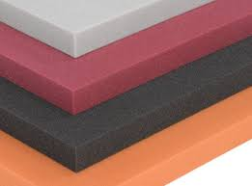This is one of the less frequently used acoustic foam options. The reason it is seldom used is because sound travels in waves and is better absorbed by foam with raised elements. In fact, with smooth panels of foam, sound can actually be reflected rather than absorbed. Smooth surface foam panels can still be useful to achieving your sound quality goals. It can be used as a foundation layer underneath textured panels for added sound proofing.

|  |  |
| --- | --- |
| Usage | Sound Absorbers |
| Brand | Orion |
| Shelf Life | 24 Months |
| Shape | Rectangular |

₹ 25/ Square Feet

**Wedge:**

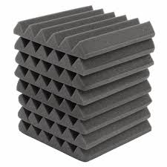Offering a cool, spiked look that makes it popular for those looking for an edgy appearance to add to their space, wedge acoustic foam absorbs sound waves efficiently thanks to the design. While this option for acoustic foam is effective, it is somewhat limited when it comes to the direction of the sound. This can make is less than ideal for larger spaces. Choosing large wedges will improve the overall sound absorbing abilities of this shape, but the directional element can make it a deal breaker for some consumers.

₹ 100/ Square Feet

|  |  |
| --- | --- |
| Usage | Sound Diffusers |
| Colour | Black |
| Packing Type | Bundle |
| Fire Proof | Yes |
| Type | Wedges |
| Minimum Order Quantity | 100 Square Feet |

**Egg crate:**

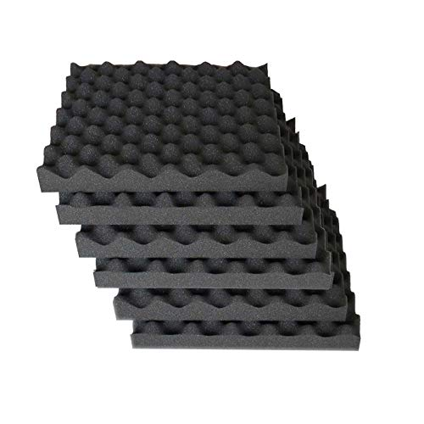With a rounded end instead of the sharp point of wedges or pyramids, eggcrate foam is one of the most affordable solutions for your [soundproofing](https://www.foambymail.com/acoustical-foam-products.html) needs. Many professionals choose to pair this foam with other solutions such as acoustic cloth for an even [better result](https://www.foambymail.com/nrc-ratings-eggcrate.html). However, this solution works fine on its own for a DIY project or for a studio on a budget.

|  |  |
| --- | --- |
| Usage/Application | Sound Diffusers |
| Fire Ratings | Fire retardant non fire retardant available |
| Density | All density |
| Sheet Size | All size |
| Thickness | All thickness |
| Minimum Order Quantity | 500 Kg |

₹ 500/ Kg

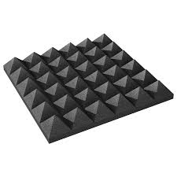**Pyramid:**

Similar to wedge, but with a pointed tip, this is a reliable option for acoustic foam with a few special considerations. While it offers dependable sound absorption comparative to other options, pyramid shaped foam tends to have a lowered rate of absorbing lower frequencies in comparison to other types. This isn't to say this type of foam can't be a viable option for certain spaces and purposes, but it is a consideration to keep in mind. There are ways of offsetting this issue with the use of corner block absorbers to pick up any low frequencies left over from the acoustic foam.

₹ 100/ Square Feet

|  |  |
| --- | --- |
| Usage | Sound Absorbers |
| Colour | Black, Blue, Orange to be a good time to explore new ways |
| Edge | Pyramid Shape |
| Thickness | 50mm |
| Material | High Density Foam |
| Minimum Order Quantity | 32 Square Feet |

**Spade:**

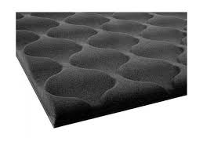  
With its less pronounced design and flatter layout, spade foam offers an attractive solution similar to smooth panels with better sound quality properties. It is adept at absorbing sound waves of various frequencies for a reliable option. While this option offers better sound quality performance than smooth textures, it should be noted that it is less effective than options such as pyramid or wedge. A variation of spade shape is wave shape. It is essentially the same in function and performance, but with a more curved surface design which gives different sound quality to a space. Many people choose to use both shapes in the same space to achieve a pleasing look with a more varied sound quality.

**Grid:**

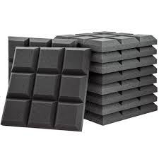Another option with a less pronounced style, grid acoustic foam uses raised lines within the surface to redirect and absorb sound waves, vibrations, and diffuse feedback. It is often chosen more for the appearance factor than performance, but that is not to say it doesn't have great performance aspects. This type of foam can be well-suited to smaller areas without many multi-directional frequencies as opposed to straight on frequencies in the direction of the foam.

|  |  |
| --- | --- |
| Usage/Application | Sound Absorbers |
| Shape | Rectangular, Square |
| Sheet Size | 11" x 11",6 x 3 Feet |
| Foam Type | PU |
| Edge | Square |

₹ 55/ Square Feet

**Firefighting foam :**

Firefighting foam is a [foam](https://en.wikipedia.org/wiki/Foam) used for [fire suppression](https://en.wikipedia.org/wiki/Fire_suppression). Its role is to cool the fire and to coat the fuel, preventing its contact with oxygen, resulting in suppression of the [combustion](https://en.wikipedia.org/wiki/Combustion). The [surfactants](https://en.wikipedia.org/wiki/Surfactant) used must produce foam in concentration of less than 1%. Other components of fire-retardant foams are organic [solvents](https://en.wikipedia.org/wiki/Solvent) (e.g., trimethyl-[trimethylene glycol](https://en.wikipedia.org/wiki/1,3-Propanediol) and [hexylene glycol](https://en.wikipedia.org/wiki/2-Methyl-2,4-pentanediol)), foam stabilizers (e.g., [lauryl alcohol](https://en.wikipedia.org/wiki/Dodecanol)), and [corrosion inhibitors](https://en.wikipedia.org/wiki/Corrosion_inhibitor).

* Low-expansion foams such as AFFF, have an expansion rate less than 20 times are low-viscosity, mobile, and can quickly cover large areas.
* Medium-expansion foams have an expansion ratio of 20–100.
* High-expansion foams have an expansion ratio over 200–1000 and are suitable for enclosed spaces such as hangars, where quick filling is needed.
* Alcohol-resistant foams contain a polymer that forms a protective layer between the burning surface and the foam, preventing foam breakdown by alcohols in the burning fuel. Alcohol-resistant foams are used in fighting fires of fuels containing [oxygenates](https://en.wikipedia.org/wiki/Oxygenate), e.g. [MTBE](https://en.wikipedia.org/wiki/MTBE), or fires of liquids based on or containing [polar](https://en.wikipedia.org/wiki/Polar_molecule) solvents.

**Application**

Every type of foam has its application. High-expansion foams are used when an enclosed space, such as a basement or hangar, must be quickly filled. Low-expansion foams are used on burning spills. AFFF is best for spills of jet fuels, FFFP is better for cases where the burning fuel can form deeper pools, and AR-AFFF is suitable for burning alcohols. The most flexibility is achieved by AR-AFFF or AR-FFFP. AR-AFFF must be used in areas where gasolines are blended with oxygenates, since the alcohols prevent the formation of the film between the FFFP foam and the gasoline, breaking down the foam, rendering the FFFP foam virtually useless.

For years, foam has been used as a fire-extinguishing medium for flammable and combustible liquids. Unlike other extinguishing agents - water, dry chemical, CO2, etc., a stable aqueous foam can extinguish a flammable or combustible liquid fire by the combined mechanisms of cooling, separating the flame/ignition source from the product surface, suppressing vapours and smothering. It can also secure for extended periods of time against reflash or reignition. Water, if used on a standard hydrocarbon fuel, is heavier than most of those liquids and if applied directly to the fuel surface, will sink to the bottom having little or no effect on extinguishment or vapour suppression. If the liquid fuel heats above 212ºF, the water may boil below the fuel surface throwing the fuel out of the contained area and spreading the fire. For this reason, foam is the primary fire-extinguishing agent for all potential hazards or areas where flammable liquids are transported, processed, stored or used as an energy source.

Before reviewing the merits of the different types of foam concentrates, there are certain terminologies associated with foam that must be understood.

**FOAM: A**

Firefighting foam is simply a stable mass of small air-filled bubbles, which have a lower density than oil, gasoline or water. Foam is made up of three ingredients - water, foam concentrate and air. When mixed in the correct proportions, these three ingredients form a homogeneous foam blanket.

**FOAM SOLUTION:**

 This is a solution of water and foam concentrate after they have been mixed together in the correct proportions.

**FOAM CONCENTRATE:**

This liquid concentrate is supplied from the manufacturer which when mixed with water in the correct proportion forms a foam solution.

**FINISHED FOAM:**

Foam solution as it exits a discharge device, having been aerated.

**DRAINAGE RATE:**

 This is the rate at which the foam solution will drain from the expanded foam mass or how long it will take for 25% of the solution to drain from the foam. This is often called the quarter life or 25% drain time. Foam that has a fast drain time is normally very fluid and mobile, spreading across the fuel surface very quickly. While foams with longer drain times are normally less mobile, they move across the fuel surface slowly.

**EXPANSION RATE:**

Volume of finished foam divided by the volume of foam solution used to create the finished foam; i.e., a ratio of 5 to 1 would mean that one gallon of foam solution after aeration would fill an empty 5-gallon container with the expanded foam mass.

**LOW EXPANSION FOAM:**

Foam aerated to an expansion ratio of between 2 to 1 and 20 to 1.

**MEDIUM EXPANSION FOAM:**

Expansion ratio between 20 to 1 and 200 to 1.

**HIGH EXPANSION FOAM:**

Expansion ratio above 200 to 1.

**SEAWATER COMPATABLE:**

Can foam concentrates be used with seawater as well as fresh water? Modern day foam concentrates can be used successfully with either sea, fresh or brackish water.

**HOW FOAM EXTINGUISHES A FLAMMABLE LIQUID FIRE:**

Fire burns because there are four elements present. These elements are heat, fuel, air (oxygen) and a chemical chain reaction. Under normal circumstances if any one of the elements is removed/interfered with, the fire is extinguished. Firefighting foam does not interfere in the chemical reaction. Foam works in the following ways:

* The foam blankets the fuel surface smothering the fire.
* The foam blanket separates the flames/ignition source from the fuel surface.
* The foam cools the fuel and any adjacent metal surfaces.
* The foam blanket suppresses the release of flammable vapours that can mix with air.

Before we review the different types of mechanical foam concentrates, please understand that there are two different basic flammable or combustible fuel groups.

* Standard hydrocarbon fuels such as gasoline, diesel, kerosene, jet fuel, etc. These products do not mix with water or are not miscible in water, i.e. these products all float on top of water and, for the most part, they do not intermix.
* Polar solvent or Alcohol type fuels are fuels that mix readily with water or are miscible in water.

It is imperative that when you are preparing to fight a flammable liquid fire, you identify which fuel group the involved flammable liquid belongs. This is necessary, as some foam concentrates are not suitable for use on the Polar solvent/Alcohol type fuel spills or fires.

Following is a list of mechanical foam concentrates that are the most common types currently used by fire fighters today.

* Aqueous Film Forming Foam (AFFF)
* Alcohol Resistant (AR-AFFF)
* Synthetic – medium or high expansion types (detergent)
* Class “A” Foam Concentrate
* Wetting Agent
* Fluor protein
* Protein
* Film Forming Fluor protein (FFFP)

**AQUEOUS FILM FORMING FOAM CONCENTRATE (AFFF):**

Available in either a 1%, 3% or 6% type concentrate. These concentrates are manufactured from synthetic type materials such as:

* Synthetic foaming agents (hydrocarbon surfactants)
* Solvents (i.e., viscosity leveller, freezing point depressant, foam booster)
* Fluoro Chemical surfactants
* Small amounts of salts
* Foam stabilizers (slow drainage, increases fire resistance)

AFFF generated foams extinguish hydrocarbon flammable liquid fires the same way as the protein or fluoroprotein foams; however, there is an additional feature. An aqueous film is formed on the surface of the flammable liquid by the foam solution as it drains from the foam blanket.

This film is very fluid and floats on the surface of most hydrocarbon fuels. This gives the AFFF unequalled speed in fire control and knockdown when used on a typical hydrocarbon spill fire. In certain circumstances, it is possible to notice the fire being extinguished by the "invisible" film before there is complete foam blanket coverage over the surface of the fuel.

AFFF foam solutions can be applied to a flammable liquid fire using either aspirating or non-aspirating discharge devices. The difference between the two is that the air-aspirating device entrains air and causes it to mix with the foam solution within the device. The non-air-aspirating device is incapable of this process.

* The AFFF/Water solution requires relatively low energy input to expand the foam solution into an expanded foam mass.
* AFFF foam solutions are unique in that in addition to forming an expanded foam mass, the liquid that drains from the blanket has a low surface tension, which gives it the ability to form the aqueous film that floats on the fuel surface.

When flow rates and pressures are similar, AFFF solutions used with a non-air-aspirating discharge device will generally discharge/throw the foam a greater distance than the foam that is discharged from the air-aspirating discharge device. A non-aspirating AFFF will generally extinguish a low vapour pressure fuel spill fire slightly faster than the foam discharged from an air-aspirating device. This is because the non- aspirated nozzle generated foam has a lower expansion and will be more fluid; therefore, it will move faster across the fuel surface. AFFF foam solutions are unique in that in addition to forming an expanded foam mass, the liquid that drains from the foam blanket has a low surface tension, which gives it the ability to form the aqueous film that floats on the fuel surface.

When using AFFF foams, application technique is not as critical as with Proteins or Fluor proteins. AFFF foam can also be used successfully with the sub-surface injection method.

**NOTE**: The sub-surface method of discharging foam into a storage tank can only be used with tanks that contain standard hydrocarbon fuels NOT polar solvent/alcohol type fuels.

The recommended application rate for AFFF 3%- 6% generated foam solution on a hydrocarbon spill fire with low water solubility is .10 gpm/sq. ft. Remember the protein and the fluoroprotein foam solutions require an application rate of .16 gpm/sq. ft.

AFFF is suitable for use in a premix state and is suitable for use with dry chemical extinguishing agents.

**ALCOHOL RESISTANT-AQUEOUS FILM FORMING FOAM (AR-AFFF):**

AR-AFFF’s are available in a 3%-6% type or 3%-3% type concentrate. Flammable liquids that readily mix with water are a more difficult fire to extinguish as opposed to a hydrocarbon fire. Polar solvent/alcohol liquids destroy any foam blanket that has been generated using standard AFFF or fluoroprotein type concentrates. Water in the generated foam blanket mixes with alcohol causing the foam blanket to collapse and disappear until the fuel surface is completely exposed again. To overcome this problem, AR-AFFF type concentrates were developed. Using plain AFFF concentrate as a base material, a high molecular weight polymer is added during the manufacturing process. When AR-AFFF is used on a polar solvent fuel fire, the polar solvent fuel tries to absorb water from the foam blanket. A polymer precipitates out forming a physical membrane/barrier between the fuel surface and foam blanket. This barrier now protects the generated foam blanket from destruction by the alcohol fuel.

AR-AFFF concentrates are very viscous. Initial impression of this type of foam concentrate may lead one to believe that the concentrate has “gelled” and somehow gone bad. However, a thick, gel-like appearance is normal. This appearance is caused by the presence of polymers, which are the main components required for polar solvent applications. Modern AR-AFFF concentrates are designed to work through proportioning equipment such as in-line eductors, bladder tanks and balanced pressure pump systems.

AR-AFFF 3%-6% type of concentrate is designed to be used at the 3% application rate when used on a standard hydrocarbon fuel fire and 6% when used on a polar solvent/alcohol fuel. Current 3% AR-AFFF type concentrate is designed for 3% application on either type group, i.e. 3% on hydrocarbons and 3% on polar solvent fuels.

When AR-AFFF is used at the correct proportioning rate on hydrocarbon fuel, firefighting performance and application rate are the same as for standard AFFF agents. An “invisible” film is formed, the speed of covering a fuel spill with the foam blanket is similar and the application technique using either air-aspirating or non-air-aspirating nozzles can be used. When used on an alcohol fire, an air-aspirating nozzle will give a better performance over the non-air-aspirating nozzle. The increased expanded foam mass generated by the air-aspirating nozzle will give a more gentle application onto the surface of the alcohol liquid fire than will the non-aspirating nozzle. The intensity of the fire, distance the foam must be thrown, and the application rate also play an important part in determining the type of nozzle and method of extinguishment. The application technique and performance factors are the same for both the 3% and the 3%- 6% types of AR-AFFF concentrates.

**SYNTHETIC/DETERGENT (High Expansion) FOAM CONCENTRATE:**

 Normally used at a concentrate rate between 1.5% to 2.5%, this type of foam concentrate is manufactured from a combination of hydrocarbon surfactants and solvents. High expansion foam solution is normally used through devices that give high expansion ratios such as the medium or high expansion type foam generators.

In areas such as a basement, mine shaft or a ship's hold where volume fire control is required, a high expansion foam generator can be used to fill an entire room with large amounts of very light expanded foam bubbles. Depending on the generator being used, high expansion ratios of 400 to 1 up to 1,000 to 1 can be achieved.

Fire control and extinction is achieved by rapid smothering and cooling. Fires involving solid material as well as flammable liquids can be controlled and extinguished using high expansion foam. It also has a special value for dealing with spillages of liquefied natural gas (LNG). A deep layer of 500 to 1 expanded foam will provide a thermal insulation barrier around the LNG spill, which reduces the heat intake, and therefore the rate of evaporation is decreased. Because of the high expansion ratios being achieved, there is very little water used; even with large discharges of the high expansion foam. High expansion foam has little water content within the bubble wall making it very light and not suitable for outdoor use. Medium expansion foam normally has an expansion of around 50 - 60 to 1. This foam is denser and can be used outdoors but is still affected by weather.

**CLASS “A” FOAM CONCENTRATE:**

This is a biodegradable mixture of foaming and wetting agents. When mixed in correct proportions with water, it can change two properties of the water. Class “A” foam will increase wetting effectiveness, which allows for greater penetration into Class “A” fuels. It also gives water a foaming ability, which allows water to remain and cling to vertical and horizontal surfaces without run off. This allows water to absorb more heat. By adding a small quantity of a Class “A” foam concentrate into a water stream, the effectiveness of the water can be increased up to 5 times.

**WETTING AGENT:**

This type of agent is very similar to Class “A” Foam with regard to increasing wetting effectiveness of the water but does not have the foaming abilities.

**FLUOROPROTEIN FOAM CONCENTRATE:**

Available in either a 3% or 6% type of concentrate. This product is manufactured using the same method as Protein but with the addition of fluorocarbon surfactants. The addition of these surfactants in the concentrate improves the performance of fluoroprotein foam over protein foam in two areas.

It makes the fluoroprotein foam more resistant to fuel contamination/pickup and makes the foam blanket more mobile when discharged onto the flammable liquid. Because the fluoroprotein foam is more resistant to fuel contamination, it allows the discharging foam to be applied directly to the fuel surface and the foam blanket will not become as saturated by fuel vapour. This type of foam can be used with a High Back Pressure Foam Maker by utilizing the sub-surface method of forcing expanded foam into the base of a cone roof storage tank containing a hydrocarbon fuel. The expanded foam enters the base of the storage tank then floats up through the flammable liquid to the surface where it covers the surface with a foam blanket. Fluoroprotein foam is sometimes used in the hydrocarbon processing industry for storage tank fire fighting. It is necessary to use with air-aspirating discharge devices. The recommended foam solution application rate on hydrocarbon spills is .16 gpm/sq. ft.

**FILM FORMING FLUORO-PROTEIN (FFFP):**

FFFP is a derivative of AFFF and fluoroprotein. These concentrates are based on fluoroprotein formulations to which an increased quantity of fluorocarbon surfactants has been added. FFFP concentrates were developed to obtain the quick knockdown of AFFF with the added burn back resistance of standard fluoroprotein foam. It appears that the FFFP concentrate performance factor lies somewhere between AFFF and fluoroprotein. FFFP concentrates do not have the quick knockdown of the AFFF’s when used on a spill fire such as an aircraft crash or a highway spill. When used on fuel in depth fires they do not have the burn back resistance of fluoroprotein. FFFP foam can be generated with either air-aspirating or non-air-aspirating nozzles. When used through a non-air-aspirated nozzle they do not provide expansion ratios as good as AFFF when used through the same type of nozzle. The application rate is .10 gpm/sq. ft. when used on a hydrocarbon spill fire.

**PROTEIN FOAM CONCENTRATE:**

Available in either a 3% or 6% type concentrate. This type of concentrate is based on hydrolysed protein, foam stabilizers and preservatives. It will produce highly stabilized air foam. Protein foam must always be used with an air aspirating type discharge device. Protein foam can become contaminated with fuel if plunged directly onto the fuel surface; therefore, the application technique for Protein foam is quite critical. The foam should be applied as gently as possible to the flammable liquid surface.

The application rate for Protein foam solution on a hydrocarbon spill fire having low water solubility is .16 gpm/sq. ft. Protein foam, because of its stability, is relatively slow moving when used to cover the surface of a flammable liquid.

**SHELF LIFE:**

Shelf life is the term used to describe the length of time which foam concentrates remain stable and usable without a significant change in their performance characteristics. Factors affecting foam concentrate long-term effectiveness include temperature exposure and cycling, storage container, air exposure, evaporation, dilution, and contamination. The effective life of CHEMGUARD foam concentrates can be maximized through optimal storage conditions and proper handling. CHEMGUARD foam concentrates have demonstrated effective firefighting performance with contents stored in the original package under proper conditions for more than 10 years.

**COMPATIBILITY:**

 Compatibility is the ability of one foam concentrate to be mixed with another concentrate of the same type and proportioning ratio without altering the chemical, physical or performance characteristics of the mixed foam concentrates. All foams are compatible when applied on a fire simultaneously.

Chemguard foam concentrates have been found to be compatible with most other foam concentrates of like quality and type. Chemguard does recommend a compatibility study to be made to determine the quality of the concentrate with which the Chemguard concentrate is to be mixed. AFFFs that are manufactured to the latest revision of Mil-F-24385 specification are mutually compatible by definition.

* **Fire-Retardant Polystyrene Foam Sheets for Building Fire:**

Fire breakout can occur in the presence of oxygen, heat, and fuel or any combustible material. Building fires are likely to spread once started and will only cease once all fuel has been used or doused. In its earliest stage, fire will prefer flammable materials, leading to combustion and growth. This may result in catastrophic consequences, with greater damage to homes or offices without a sufficient emergency or fire prevention plan.

To mitigate risk, builder specifiers are exploring the use of alternative building materials such as polystyrene, which has proven to resist fire better than traditional concrete, wood, and metal. Foamex have modified all their polystyrene sheets with fire retardant additives to meet the most stringent fire safety requirements as set by Australian Building Codes.

When in direct contact with flame, these foams will burn yet will not combust. They have a very slow fire propagation and will not continue to burn once the source of the fire is removed. Comprised of more than 90% air with no CFCs or HCFCs gases, fire-retardant polystyrene foam sheets are safe for occupants and do not produce any toxic gases when burning.

Foamex offers a comprehensive range of fire-retardant polystyrene foam sheets, with each providing additional insulation and durability values.

**[Flame-Retardant Silicone Foam Sheets and Strips:](https://www.mcmaster.com/fire-retardant-foam/flame-retardant-silicone-foam-sheets-and-strips/)**

[[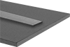](https://www.mcmaster.com/fire-retardant-foam/flame-retardant-silicone-foam-sheets-and-strips/)](https://www.mcmaster.com/fire-retardant-foam/flame-retardant-silicone-foam-sheets-and-strips/)

[Prevent the spread of flames with these self-extinguishing silicone foam sheets and strips.](https://www.mcmaster.com/fire-retardant-foam/flame-retardant-silicone-foam-sheets-and-strips/)

[Foam, but not the adhesive, meets UL flame extinguishing specifications. Silicone maintains its flexibility across a wide range of temperatures. This foam has closed-cell construction, which restricts water, air, and gases from being absorbed.](https://www.mcmaster.com/fire-retardant-foam/flame-retardant-silicone-foam-sheets-and-strips/)

* [Colour: Grey](https://www.mcmaster.com/fire-retardant-foam/flame-retardant-silicone-foam-sheets-and-strips/)
* [Temperature Range: -85° to 400° F](https://www.mcmaster.com/fire-retardant-foam/flame-retardant-silicone-foam-sheets-and-strips/)
* [Cell Type: Closed](https://www.mcmaster.com/fire-retardant-foam/flame-retardant-silicone-foam-sheets-and-strips/)
* [For Use Outdoors: Yes](https://www.mcmaster.com/fire-retardant-foam/flame-retardant-silicone-foam-sheets-and-strips/)
* [Density: 12 lbs./cu. ft.](https://www.mcmaster.com/fire-retardant-foam/flame-retardant-silicone-foam-sheets-and-strips/)
* [Pressure to Compress 25%: 3 psi (Ultra Soft)](https://www.mcmaster.com/fire-retardant-foam/flame-retardant-silicone-foam-sheets-and-strips/)
* [Tensile Strength Rating: Not Rated](https://www.mcmaster.com/fire-retardant-foam/flame-retardant-silicone-foam-sheets-and-strips/)
* [Oil-Resistance Rating: Not Rated](https://www.mcmaster.com/fire-retardant-foam/flame-retardant-silicone-foam-sheets-and-strips/)

**[Heat-Reflecting Flame-Retardant Silicone Foam Sheets:](https://www.mcmaster.com/fire-retardant-foam/heat-reflecting-flame-retardant-silicone-foam-sheets/)**

[[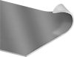](https://www.mcmaster.com/fire-retardant-foam/heat-reflecting-flame-retardant-silicone-foam-sheets/)](https://www.mcmaster.com/fire-retardant-foam/heat-reflecting-flame-retardant-silicone-foam-sheets/)

[A thin layer of aluminized fiberglass on this silicone foam reflects heat to protect sensitive equipment.](https://www.mcmaster.com/fire-retardant-foam/heat-reflecting-flame-retardant-silicone-foam-sheets/)

[Foam, but not the adhesive, meets UL flame extinguishing specifications. Silicone maintains its flexibility across a wide range of temperatures. This foam has open-cell construction, which allows water, air, and gases to be absorbed. These sheets have an ultra-smooth texture for a sleek surface that's easy to wipe down.](https://www.mcmaster.com/fire-retardant-foam/heat-reflecting-flame-retardant-silicone-foam-sheets/)

* Colour: White with Silver Face
* Temperature Range: -60° to 390° F
* Cell Type: Open
* For Use Outdoors: Yes
* Density: 12 lbs. /cu. ft.
* Pressure to Compress 25%: 3 psi (Ultra Soft)
* Tensile Strength Rating: Not Rated
* Oil-Resistance Rating: Not Rated

**[Resilient Flame-Retardant Silicone Foam Sheets and Strips:](https://www.mcmaster.com/fire-retardant-foam/resilient-flame-retardant-silicone-foam-sheets-and-strips/)**

[[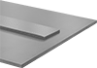](https://www.mcmaster.com/fire-retardant-foam/resilient-flame-retardant-silicone-foam-sheets-and-strips/)](https://www.mcmaster.com/fire-retardant-foam/resilient-flame-retardant-silicone-foam-sheets-and-strips/)

[Even after extended compression, these sheets and strips will bounce back to shape.](https://www.mcmaster.com/fire-retardant-foam/resilient-flame-retardant-silicone-foam-sheets-and-strips/)

[Foam, but not the adhesive, meets UL flame extinguishing specifications. Silicone maintains its flexibility across a wide range of temperatures. This foam has open-cell construction that allows water, air, and gases to be absorbed.](https://www.mcmaster.com/fire-retardant-foam/resilient-flame-retardant-silicone-foam-sheets-and-strips/)

* [Colour: White](https://www.mcmaster.com/fire-retardant-foam/resilient-flame-retardant-silicone-foam-sheets-and-strips/)
* [Temperature Range: -60° to 390° F](https://www.mcmaster.com/fire-retardant-foam/resilient-flame-retardant-silicone-foam-sheets-and-strips/)
* [Cell Type: Open](https://www.mcmaster.com/fire-retardant-foam/resilient-flame-retardant-silicone-foam-sheets-and-strips/)
* [For Use Outdoors: Yes](https://www.mcmaster.com/fire-retardant-foam/resilient-flame-retardant-silicone-foam-sheets-and-strips/)
* [Density: 12 lbs./cu. ft.](https://www.mcmaster.com/fire-retardant-foam/resilient-flame-retardant-silicone-foam-sheets-and-strips/)
* [Pressure to Compress 25%: 3 psi (Ultra Soft)](https://www.mcmaster.com/fire-retardant-foam/resilient-flame-retardant-silicone-foam-sheets-and-strips/)
* [Tensile Strength Rating: Fair](https://www.mcmaster.com/fire-retardant-foam/resilient-flame-retardant-silicone-foam-sheets-and-strips/)
* [Oil-Resistance Rating: Not Rated](https://www.mcmaster.com/fire-retardant-foam/resilient-flame-retardant-silicone-foam-sheets-and-strips/)

**[Food Industry High-Temperature Silicone Foam Sheets and Strips:](https://www.mcmaster.com/fire-retardant-foam/food-industry-high-temperature-silicone-foam-sheets-and-strips/)**

[[testString](https://www.mcmaster.com/fire-retardant-foam/food-industry-high-temperature-silicone-foam-sheets-and-strips/)](https://www.mcmaster.com/fire-retardant-foam/food-industry-high-temperature-silicone-foam-sheets-and-strips/)

[Seal and damp vibration around high-temperature food-service equipment with these silicone foam sheets and strips.](https://www.mcmaster.com/fire-retardant-foam/food-industry-high-temperature-silicone-foam-sheets-and-strips/)

[The foam, but not the adhesive, is made of FDA-listed materials for use with food. Silicone maintains its flexibility across a wide range of temperatures. These sheets and strips have an ultra-smooth texture for a sleek surface that's easy to wipe down.](https://www.mcmaster.com/fire-retardant-foam/food-industry-high-temperature-silicone-foam-sheets-and-strips/)

* Colour: White
* Temperature Range: -60° to 390° F
* Cell Type: Open
* For Use Outdoors: Yes
* Density: 12 lbs./cu. ft.
* Pressure to Compress 25%: 3 psi (Ultra Soft)
* Tensile Strength Rating: Fair
* Oil-Resistance Rating: Not Rated

**[Flame-Retardant Super-Cushioning Polyurethane Foam Sheets and Strips](https://www.mcmaster.com/fire-retardant-foam/flame-retardant-super-cushioning-polyurethane-foam-sheets-and-strips/)**

[[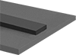](https://www.mcmaster.com/fire-retardant-foam/flame-retardant-super-cushioning-polyurethane-foam-sheets-and-strips/)](https://www.mcmaster.com/fire-retardant-foam/flame-retardant-super-cushioning-polyurethane-foam-sheets-and-strips/)

[When these sheets and strips are exposed to flames, the surface chars to create a protective barrier that prevents melting, dripping, and the possibility of spreading fire.](https://www.mcmaster.com/fire-retardant-foam/flame-retardant-super-cushioning-polyurethane-foam-sheets-and-strips/)

[Foam, but not the adhesive, meets UL 94HF1. This foam is widely used in packaging applications to absorb shock and damp vibration. Foam has open-cell construction, which allows water, air, and gases to be absorbed.](https://www.mcmaster.com/fire-retardant-foam/flame-retardant-super-cushioning-polyurethane-foam-sheets-and-strips/)

* [Colour: Black](https://www.mcmaster.com/fire-retardant-foam/flame-retardant-super-cushioning-polyurethane-foam-sheets-and-strips/)
* [Temperature Range: -40° to 190° F](https://www.mcmaster.com/fire-retardant-foam/flame-retardant-super-cushioning-polyurethane-foam-sheets-and-strips/)
* [Cell Type: Open](https://www.mcmaster.com/fire-retardant-foam/flame-retardant-super-cushioning-polyurethane-foam-sheets-and-strips/)
* [For Use Outdoors: Yes](https://www.mcmaster.com/fire-retardant-foam/flame-retardant-super-cushioning-polyurethane-foam-sheets-and-strips/)
* [Density: Extra Soft: 15 lbs./cu. ft.; Soft: 20 lbs./cu. ft.](https://www.mcmaster.com/fire-retardant-foam/flame-retardant-super-cushioning-polyurethane-foam-sheets-and-strips/)
* [Pressure to Compress 25%: Extra Soft: 6 psi; Soft: 10 psi](https://www.mcmaster.com/fire-retardant-foam/flame-retardant-super-cushioning-polyurethane-foam-sheets-and-strips/)
* [Tensile Strength Rating: Good](https://www.mcmaster.com/fire-retardant-foam/flame-retardant-super-cushioning-polyurethane-foam-sheets-and-strips/)
* [Oil-Resistance Rating: Not Rated](https://www.mcmaster.com/fire-retardant-foam/flame-retardant-super-cushioning-polyurethane-foam-sheets-and-strips/)

**[Resilient Polyurethane Foam Sheets and Strips](https://www.mcmaster.com/fire-retardant-foam/resilient-polyurethane-foam-sheets-and-strips/)**

[[testString](https://www.mcmaster.com/fire-retardant-foam/resilient-polyurethane-foam-sheets-and-strips/)](https://www.mcmaster.com/fire-retardant-foam/resilient-polyurethane-foam-sheets-and-strips/)

[Even after extended compression, these high-performance polyurethane foam sheets and strips bounce back to shape faster than any other foam we offer. Also known as Poron urethane, they also stand up to wear caused by rubbing and scraping.](https://www.mcmaster.com/fire-retardant-foam/resilient-polyurethane-foam-sheets-and-strips/)

[Use them in packaging applications to absorb shock and damp vibration. This foam has open-cell construction, which allows water, air, and gases to be absorbed. These sheets and strips have an ultra-smooth texture for a sleek surface that's easy to wipe down.](https://www.mcmaster.com/fire-retardant-foam/resilient-polyurethane-foam-sheets-and-strips/)

* [Colour: Black](https://www.mcmaster.com/fire-retardant-foam/resilient-polyurethane-foam-sheets-and-strips/)
* [Temperature Range: -40° to 190° F](https://www.mcmaster.com/fire-retardant-foam/resilient-polyurethane-foam-sheets-and-strips/)
* [Cell Type: Open](https://www.mcmaster.com/fire-retardant-foam/resilient-polyurethane-foam-sheets-and-strips/)
* [For Use Outdoors: Yes](https://www.mcmaster.com/fire-retardant-foam/resilient-polyurethane-foam-sheets-and-strips/)
* [Density: Extra Soft: 15 lbs./cu. ft.; Soft: 20 lbs./cu. ft.](https://www.mcmaster.com/fire-retardant-foam/resilient-polyurethane-foam-sheets-and-strips/)
* [Pressure to Compress 25%: Extra Soft: 6 psi; Soft: 10 psi](https://www.mcmaster.com/fire-retardant-foam/resilient-polyurethane-foam-sheets-and-strips/)
* [Tensile Strength Rating: Good](https://www.mcmaster.com/fire-retardant-foam/resilient-polyurethane-foam-sheets-and-strips/)
* [Oil-Resistance Rating: Not Rated](https://www.mcmaster.com/fire-retardant-foam/resilient-polyurethane-foam-sheets-and-strips/)

**[Ultra-Conformable Polyurethane Foam Sheets and Strips](https://www.mcmaster.com/fire-retardant-foam/ultra-conformable-polyurethane-foam-sheets-and-strips/)**

[[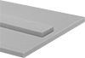](https://www.mcmaster.com/fire-retardant-foam/ultra-conformable-polyurethane-foam-sheets-and-strips/)](https://www.mcmaster.com/fire-retardant-foam/ultra-conformable-polyurethane-foam-sheets-and-strips/)

[Commonly called memory foam and Confor, these sheets and strips have the best cushioning qualities of all the foam we offer.](https://www.mcmaster.com/fire-retardant-foam/ultra-conformable-polyurethane-foam-sheets-and-strips/)

[They take several seconds to recover from compression, but maintain their resiliency over time. These sheets and strips are widely used in packaging applications to absorb shock and damp vibration; they are also found in seat cushions. Foam has open-cell construction, which allows water, air, and gases to be absorbed.](https://www.mcmaster.com/fire-retardant-foam/ultra-conformable-polyurethane-foam-sheets-and-strips/)

* [Colour: Yellow, Pink, Blue, or Green](https://www.mcmaster.com/fire-retardant-foam/ultra-conformable-polyurethane-foam-sheets-and-strips/)
* [Temperature Range: 50° to 120° F](https://www.mcmaster.com/fire-retardant-foam/ultra-conformable-polyurethane-foam-sheets-and-strips/)
* [Cell Type: Open](https://www.mcmaster.com/fire-retardant-foam/ultra-conformable-polyurethane-foam-sheets-and-strips/)
* [For Use Outdoors: No](https://www.mcmaster.com/fire-retardant-foam/ultra-conformable-polyurethane-foam-sheets-and-strips/)
* [Density: 6 lbs./cu. ft.](https://www.mcmaster.com/fire-retardant-foam/ultra-conformable-polyurethane-foam-sheets-and-strips/)
* [Pressure to Compress 25%: Yellow: 0.2 psi (Ultra Soft); Pink: 0.4 psi (Ultra Soft); Blue 0.6 psi (Ultra Soft); Green: 0.8 psi (Ultra Soft)](https://www.mcmaster.com/fire-retardant-foam/ultra-conformable-polyurethane-foam-sheets-and-strips/)
* [Tensile Strength Rating: Fair](https://www.mcmaster.com/fire-retardant-foam/ultra-conformable-polyurethane-foam-sheets-and-strips/)
* [Oil-Resistance Rating: Not Rated](https://www.mcmaster.com/fire-retardant-foam/ultra-conformable-polyurethane-foam-sheets-and-strips/)

**[Multipurpose Neoprene Foam Sheets and Strips](https://www.mcmaster.com/fire-retardant-foam/multipurpose-neoprene-foam-sheets-and-strips-6/)**

[[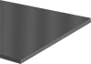](https://www.mcmaster.com/fire-retardant-foam/multipurpose-neoprene-foam-sheets-and-strips-6/)](https://www.mcmaster.com/fire-retardant-foam/multipurpose-neoprene-foam-sheets-and-strips-6/)

[In addition to having good resistance to water, sunlight, and oxidation, these neoprene foam sheets and strips resist swelling when they come into contact with oil.](https://www.mcmaster.com/fire-retardant-foam/multipurpose-neoprene-foam-sheets-and-strips-6/)

[Closed-cell foam restricts water, air, and gases from being absorbed](https://www.mcmaster.com/fire-retardant-foam/multipurpose-neoprene-foam-sheets-and-strips-6/)

* Colour: Black
* Temperature Range: -70° to 200° F
* Cell Type: Closed
* For Use Outdoors: Yes
* Density: Ultra Soft: 10 lbs./cu. ft.; Soft: 15 lbs./cu. ft.; Medium: 19 lbs./cu. ft.
* Pressure to Compress 25%: Ultra Soft: 3 psi; Soft: 12 psi; Medium: 17 psi
* Tensile Strength Rating: Ultra Soft: Fair; Soft and Medium: Good
* Oil-Resistance Rating: Good

**[Flame-Retardant Oil-Resistant Blended Buna-N Foam Sheets and Strips](https://www.mcmaster.com/fire-retardant-foam/flame-retardant-oil-resistant-blended-buna-n-foam-sheets-and-strips/)**

[[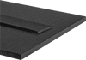](https://www.mcmaster.com/fire-retardant-foam/flame-retardant-oil-resistant-blended-buna-n-foam-sheets-and-strips/)](https://www.mcmaster.com/fire-retardant-foam/flame-retardant-oil-resistant-blended-buna-n-foam-sheets-and-strips/)

[This foam meets UL fire extinguishing specifications. It's made from a blend of Buna-N, neoprene, and vinyl to offer good resistance to oil.](https://www.mcmaster.com/fire-retardant-foam/flame-retardant-oil-resistant-blended-buna-n-foam-sheets-and-strips/)

[This foam has closed-cell construction, which restricts water, air, and gases from being absorbed.](https://www.mcmaster.com/fire-retardant-foam/flame-retardant-oil-resistant-blended-buna-n-foam-sheets-and-strips/)

* Colour: Black
* Temperature Range: -40° to 200° F
* Cell Type: Closed
* For Use Outdoors: Yes
* Density: Ultra Soft: 5 lbs./cu. ft.; Extra Soft: 7 lbs./cu. ft.; Soft: 8 lbs./cu. ft.
* Pressure to Compress 25%: Ultra Soft: 4 psi; Extra Soft: 7 psi; Soft: 11 psi
* Tensile Strength Rating: Ultra Soft: Fair; Extra Soft and Soft: Good
* Oil-Resistance Rating: Good

## Materials used in Mattresses:

### **Foam:**

A soft, movement-absorbing material that helps with temperature regulation and pressure point relief. Some common types of foam include memory foam, gel memory foam, polyurethane foam, and viscoelastic foam (also known as "rebounded foam").

* **Application in mattress:**

## Polyurethane Foam mattress:

[Polyurethane foam](https://www.thesleepjudge.com/polyurethane-foam-comfort-and-support-layers/) is perhaps the most widely used material in bedding (as well as a whole host of other applications). Low density polyurethane is favoured by many manufacturers as a top layer material to create a soft initial feel (that doesn’t last very long) but does make for a good first impression.

Higher grade polyurethane (i.e. with higher density), is used to create highly resilient and progressively resistant support cores that hold up the more pressing parts of your body, that would otherwise sink through a soft comfort layer.

The durability of polyurethane is dependent upon its density: low density foams will start showing signs of deterioration a couple of years into their use, while high resilience foams will last for years without any tangible alteration in their performance.

### **The Pros and Cons**

#### **Pros**

* Generally inexpensive.
* Available in a wide range of firmness ratings.
* Can provide both resilient support and pressure relief simply by varying density and firmness.
* Simple to maintain.
* Cooler

#### **Cons**

* Not as durable as memory foam.
* Doesn’t provide conforming support.
* Doesn’t completely eliminate motion transfer.

### **Comfort and Pressure Relief:**

Even low density polyurethane can offer decent springy support (though it won’t last very long, which is why I don’t recommend it at all, unless the mattress is to be used only sparingly). Moving on to HD and HR grade polyurethane – you can get resilient comfort that will last you for years, provided that the manufacturer does not go crazy with the thickness for short term good impressions.

Resilient comfort means that you’ll be getting a mattress that bounces back after you put pressure on it – the degree of firmness will determine how much it reacts to your body weight. For instance, the softer varieties of high density polyurethane foam could relax your pressure points through their compressibility alone – and at a much lower cost than the other candidate at that, but they’ll be less bouncy as a consequence.

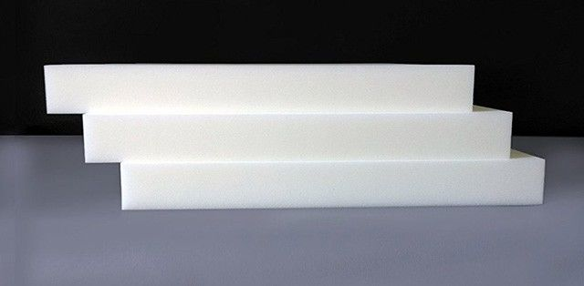

### **Heat Retention and Breathability**

While not the coolest material around, polyfoam does have an open cell structure which makes it automatically better at thermal conduction away from your body.

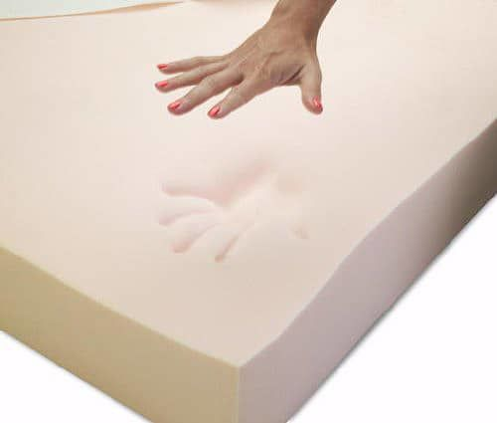

### **Durability**

For both viscoelastic and polyurethane, durability is largely dependent on the density of the material.

Low density polyurethane foam starts to sag after a couple of years – sooner if it is used more ‘intensely’, but high quality, high density foam (with density north of 2 lb./cu.ft.) can be expected to last far longer. That said, it still won’t age as gracefully as viscoelastic does.

## Memory Foam mattress

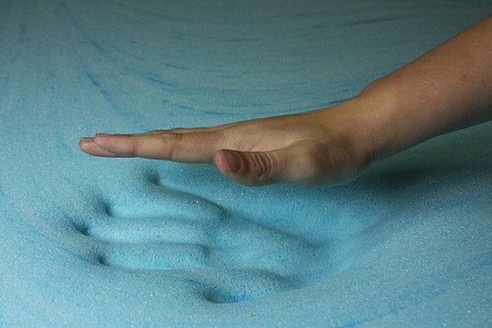

Memory foam is a viscoelastic material: it is known for its ability to both absorb and redistribute pressure from a body falling upon it, enabling it to form a conforming cradle that matches your sleeping style – this in turn results in pressure being taken away from the hard points e.g. hips and shoulders for a side sleeper, so that a more natural spinal position can be achieved.

Viscoelastic foam by itself isn’t able to provide total support – pressure relief is more its forte. For a mattress to be both supportive and pressure relieving, the base will need to comprise of a harder, more resilient material such as HD polyfoam.

In terms of composition, viscoelastic foam is closely related to regular polyurethane, with the exception that it uses additional chemicals to achieve its viscoelastic nature. High quality viscoelastic foam – that is to say, with a density surpassing 4 lb./cu.ft., usually retains its conforming ability for much longer than other types of foam.

### **The Pros and Cons**

#### **Pros**

* Conforms to the shape of your body.
* Provides personalized pressure relief.
* Good at motion isolation.
* Can provide cradling support when combined with a decent base.

#### **Cons**

* Pricey.
* Hot.
* Sensitive to temperature extremes.
* Initial chemical smell.



### **Memory Foam Vs Low Density Foam**

Viscoelastic foam provides what is referred to by some as ‘dead’ support – this is because it absorbs most of the impact of your body, and reflects it minimally, so it lacks the springiness or ‘resilience’ of polyurethane.

Furthermore, because of its ability to melt away locally according to your body heat and weight, it offer hard support at all – so more than a few inches of viscoelastic in a comfort layer can lead to spinal misalignment, especially for weighty individuals (unless there’s a harder support layer underneath, as is the norm with modern mattresses).

Low density polyurethane (under 1.5 lb./cu.ft.), while lacking the viscoelastic qualities of memory foam, offers the same soft support but with a bit more spring. However, it too won’t be able to sustain the major weight of your body, and will require additional support materials underneath to fully hold up your body.

### **Memory Foam Vs High Density Foam**

As mentioned before, viscoelastic foam does not offer any hard support. However, high density (1.5 to 2 lb./cu.ft.) and high resilience (2.5 lb./cu.ft. density and 2.4 support factor) foams can be made to offer both soft support and deep support.

Depending on the degree of firmness as well as the quality, HD and HR foam can be used reliably in any support role, whereas viscoelastic is restricted for use virtually exclusively in comfort layers. In fact, many reputable local manufacturers combine high density viscoelastic foam / high density foam mattress hybrids that offer soft surface conformity and deep support simultaneously.

### **Comfort and Pressure Relief**

Thanks to its conforming, cradling nature, viscoelastic foam can target the parts of your body that tend to stick out and create awkward spinal positions that result in back ache. It shapes itself around these parts and alleviates pressure from them, thereby yielding superior pain relief.

That said, the overall feel you get from a viscoelastic mattress will be of sleeping ‘in’ the mattress rather than sleeping ‘on’ it – so if you’re expecting something with a bit more kick, this isn’t the best choice.

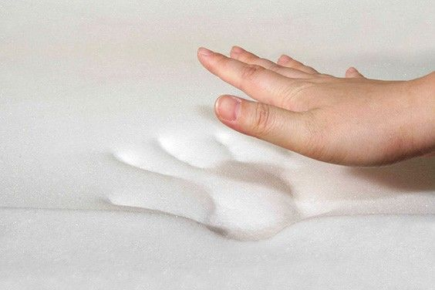

### **Heat Retention and Breathability**

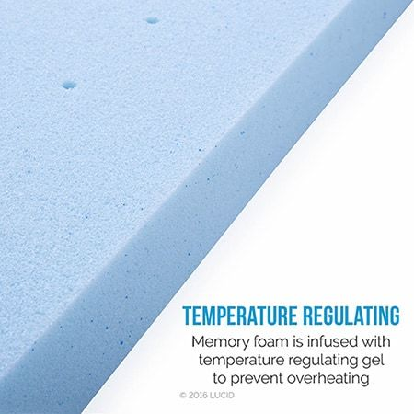

Traditional viscoelastic foam, with its non-breathable closed cell structure, has a tendency to run hot – an issue compounded by its inherent responsivity to heat which causes it to sink further inwards, thereby making the cradle even hotter.

Open cell memory foam was developed to mitigate this very issue – and it has been successful to a varying degree. Further down the road, manufacturers started to incorporate special gel beads inside the open cell structure to enhance heat transfer and breathability even further.

At the end of the day though, viscoelastic is still the hottest type of bedding material, and is not recommended for tropical settings, particularly when no active air conditioning is available.

### **Firmness**

Memory foam, unless it is of a high compressive modulus and appropriately thick (over 3”), is very soft – it has to be, so it can sink in and create that enveloping cradle it is so famed for. On the other hand, polyurethane is available in varying degrees of firmness – ranging from very soft to very firm.

In general, firmness is characterized by the material’s Indentation Load-Deflection (or Indentation Force-Deflection) value which is gauged from a standardized physical test. The greater the ILD value, the higher the firmness of the mattress.

10 (super soft) to 14 (semi-rigid) is a typical ILD range for viscoelastic foam mattresses, while that for polyurethane ranges from 6 to 45 ILD. It is evident then, which of the two materials has more variation in firmness.

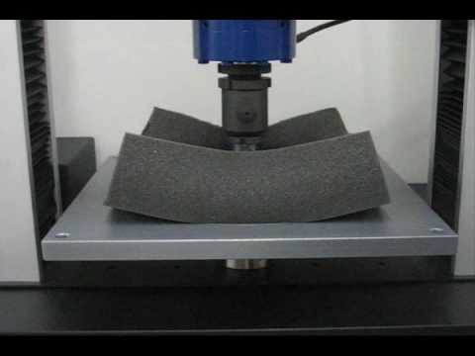

### **Durability**:

For both viscoelastic and polyurethane, durability is largely dependent on the density of the material.

Viscoelastic mattresses with a density greater than 4 lb./cu.ft. Will last for several years, and retain their characteristics without any visible change. Even when viscoelastic foam does start to deteriorate, it becomes softer instead of settling into a hard lump – eventually, it begins to feel like you’re sleeping in a fluid, and that’s the time to replace it.

## Latex Mattress

### [Latex used in a mattress is harvested from rubber trees](https://www.awarasleep.com/) which offer greater elasticity and faster recovery time to return to its original shape.  Latex mattresses are known to be more firm than a memory foam mattress and feature a distinct bounciness bounce even. There are three types available, and these are natural, synthetic, as well as blended variations.

### **NATURAL LATEX FOAM**

### As the name suggests, this foam is made from raw rubber tree sap and processed to produce foam layers. If you are looking for a natural feel to your mattress, this is a good option to consider. If you come across a certified organic natural latex mattress, it means that only the purest or organic materials are used and that there will be minimal off-gassing to worry about.

### **SYNTHETIC LATEX FOAM**

### This type of latex foam can be made from various synthetic materials that are often constructed from styrene-butadiene rubber or SBR. You may notice that it has a similar feel to an all-natural latex mattress, but there are some who will notice that it has less bounce to it.

### In terms of the manufacturing process, there are two options that are used for this type of mattress, and these are:

### [**Dunlop latex mattress**](https://www.awarasleep.com/mattress)

### This process is where latex is poured into the mold in one continuous pour. The result is that you will end up with a denser foam at the bottom, while the top is softer.

### [**Talalay latex mattress**](https://www.awarasleep.com/mattress)

### Natural Talalay latex foam is formed using the Talalay process, where the mold is partially filled with latex then air is introduced by vacuum output to help expand the latex until it reaches its desired shape. This way, you are left with a less dense latex material.

## Benefits of Latex Mattress

Since we are talking about latex vs. memory foam, it is also important to know what benefits you’ll get from each. Here’s what you can get when you opt for a latex mattress.

### **HYPOALLERGENIC**

One of the benefits of opting for a [natural latex mattress](https://www.awarasleep.com/mattress) is that it is hypoallergenic which means that it’s not prone to allergens that can irritate your nasal passages when you sleep. If you have some form of airborne allergy, you may find this type of mattress worth investing in.

### **NATURALLY RESISTANT TO DUST MITES**

Some mattresses are more prone to mold, bacteria, dust mites, and even bed bugs because of their make and their design, but with a latex mattress, it naturally repels critters compared to a traditional mattress.

### **COOLER TEMPERATURE**

Another benefit to choosing a latex mattress is that latex tends to be cooler compared to memory foam because of its open cell structure. Although latex may still conduct some form of heat, it is not as hot as what you may experience with memory foam.

### **ENVIRONMENT-FRIENDLY**

What can you get out of a natural latex mattress? Since natural latex is sustainably sourced and the process that it undergoes is considered safer for the environment, you are actually sleeping on a bed that is eco-friendly.

### **DURABILITY**

### In terms of durability, latex mattresses stand out as they tend to last longer compared to others.

1. **Rebounded/Bonded foam:**

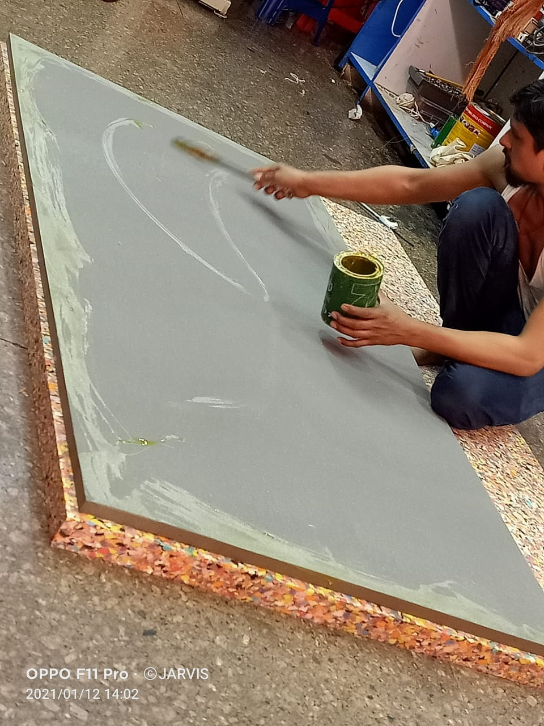

Bonded foam is a generally firm and elastic mattress that gets this unique physical attribute from different foam pieces shredded and combined. Rebounded foam is an excellent option for people looking for comfort and support in balance. You can use [rebounded foam in Orthopaedics](https://www.kingkoil.in/orthomedical-mattresses) because it tends to have a firmer surface layer to support and provide relief. Moreover, rebounded foam's quality and density depend on the manufacturing process.  
At King Koil, we strive for the best quality rebounded foam by using in house newly manufactured material for our [Orthobond](https://www.kingkoil.in/back-support-mattress) and other mattress options. Rebounded foam is an excellent option for people who want the firm elastic motion without investing in innerspring mattresses. The different mattress shreds inside help support body weight and help conform to your body. This is especially useful for people who want a healthy balance of comfort and support without tipping too much on either side.

* **Cons of Bonded Foam:**
* **Hot mattress:**

 While this can be an advantage or disadvantage depending upon climate and body type, most people do not like the temperature isolation. The bonded foam tends to hold on to heat and doesn't distribute heat as quickly. While this is true for most high-density foams, it isn't easy to get an affordable foam mattress to regulate body heat quickly.

* **Density and form:**

Rebounded foam's density is the factor that determines its durability. Although it is a pieced-together version, it still needs high-quality foam to be firm enough to have structural integrity. Moreover, the density of a bonded foam depends on how many pieces the manufacturing process uses and its material. Even after this, because of the nature of the glued together structure, it can lose its form to some extent after some years. Ideally, it should last for at least 3-5 years without much loss if it has an excellent quality of foam material in use.

1. **Coir mattress**

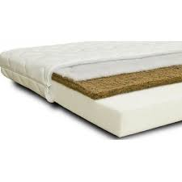This is the uniquely crafted bedding using the coir fibres or coconut fibre. The essential element which is used to make the [coir mattress](https://napcloud.in/the-mattress/coconap/) is coir while another secondary material is also used because sleeping on the coir alone is not at all possible.  
Further, Polyurethane high-density foam is the matter that is used to cover the coir over which a layer of cotton is also attached to give the final texture to the mattress. It is mainly originated in India that offers various benefits to back.

* **Coir mattresses:**

Coir mattresses are comfortable to manufacture and sustain. This makes them inexpensive, and you don't have to think twice before purchasing them. But the general life, as well as comfort, are what might cause double-thoughts. With that said, there are two kinds of coir mattresses that you can find in the market

* **Rubberized coir mattress:**

This is the more premium version of a coir mattress, where one uses latex foam in the comfort layer. This helps the coir mattress retain its visible shape slightly longer and offer a more premium comfort because of the latex foam.

* **Hybrid coir mattress:**

Generally, coir mattresses need different kinds of materials for support and comfort layers. While coir may make up the bulk of the mattress, it may use one or more foam types to make up the mattress. As a result, you get to experience the support from the bulk of the coir and comfort from different materials like latex, PU Foam, or foams that do not disintegrate quickly.

* Coir foam Mattress is made of coir which is a natural fibre that is obtained by removing the coconut husk. This makes the coir foam mattress hard and also very beneficial for your health. Let's look at some key **benefits of this mattress type:**
* Coir foam mattress provides a very good ventilation system. This helps our body to naturally calm down.
* Having hygroscopic quality, you can sleep much comfortably on coir foam mattress as it easily absorbs the moisture in the air.
* Also being an eco-friendly fibre Coir foam mattress is made without any harmful or chemical substance use in manufacturing. This makes it good for both health and environment.
* This mattress also has a natural springy quality and provides much more support to the body.
* [Coir foam mattress](https://www.springwel.in/17-coir-mattress) is a boon for people who are very allergic to dust and dirt. Since coir has anti dust quality which prevents allergies.
* It is also flame resistant which gives them an extra advantage over conventional [mattresses](https://www.springwel.in/42-mattresses). Supposedly, if there is a fire in your house coir foam mattress will still be safe.
* Coir provides the required support and firmness to human body and helps you get a sound and perfect sleep in the posture you feel comfortable in. This helps your spine to get the needed rest.
* They are also very good insulators and are completely moth proof.

1. **Spring Mattress**

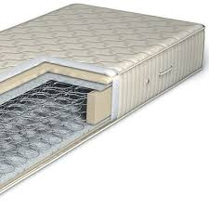

A spring mattress is made of the pocket-coil system covered with fabric. The manufacturing process of such a mattress is quite easy and comes with a lower price tag along with a lifespan of seven to ten years. But if you are looking for a mattress with better back support and good comfort, then a spring mattress is not for you. It is not good for your back as well as spinal arrangement. As it cannot distribute your body weight, it causes much pain during sleep. Furthermore, a spring mattress unable to address the body temperature of the user like other mattresses. It also requires more maintenance as compared to the coir ones, and you have to rotate them in a fixed period.

Several factors can influence how a spring bed feels. Coil count is an important factor; most quality beds will have around 400 coils or more in a queen size mattress. However, keep in mind that a higher coil count does not necessarily equal a higher quality bed, as there are many factors at play.

Spring beds will also often have foam layers surrounding the coils, as well as a plush or polyfoam comfort layer on top. The quality, material, and thickness of these layers can greatly influence the comfort and feel of the mattress.

Coil gauge, referring to the thickness of the wire used, influences the firmness of the bed. Manufacturers will clearly list the intended firmness of each mattress model, so checking the coil gauge is not too important for consumers.

Lastly, the various types of springs used in these mattresses will impact their comfort and support ratings.

### **Types of Springs/Coils**

1. **Bonnell Coils** –

Bonnell coils are the original design used in the first spring mattresses, and some manufacturers still use them today. They are hourglass-shaped and can be made to be either soft or firm depending on the wire gauge. Bonnell coils are simple and cost-effective, so many mattresses utilize them.

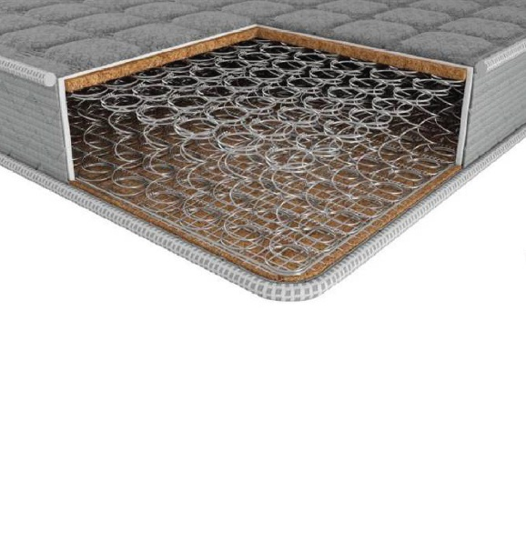

The oldest type of [coil](https://beds.org/blog/spring-to-sleep/) used in [mattresses](https://beds.org/blog/mattresses-beds-and-how-we-sleep/) is the Bonnell coil. Bonnell coil mattresses are often called “traditional mattresses” or “traditional [innerspring mattresses](http://www.beds.org/best-innerspring-mattress.php).” Other types of coils have been developed since, but they all originate in the Bonnell coil.

Bonnell coils themselves were developed from buggy seat springs. They are hourglass shaped. The ends are knotted, the end of the wire twisted around the coil wire, making a full circle (see the single coil in the illustration above). The coils are attached to each other in rows by a helical wire (see middle picture). And all the rows together in a heavy wire (or perimeter rod) frame form the innerspring unit.

The hourglass shape of a Bonnell coil gives it a dual action. The narrower middle is “softer” with an initial yield when a weight is placed on it. Then the wider ends increase resistance for “deep down” support.

The narrow middle section is a weak point in this type of coil, making it prone to distortion or breakage leading to mattress sagging. Nevertheless, Bonnell mattresses give good support when new. Thicker-gauge wire and/or a less-pronounced hourglass figure make a Bonnell coil more durable. At the same time, this makes the innerspring firmer. This is the reason Bonnell coils are usually found in firmer mattress models. A taller coil or fewer turns can make heavier-gauge coils less firm without sacrificing durability.

Bonnell coils cost less to manufacture and assemble than other types. Therefore they are usually found in lower-priced entry level [innerspring mattresses](https://beds.org/blog/spring-beds-the-good-the-bad-and-the-ugly/). If a sleeper or a couple are not too heavy, a well-designed and made Bonnell coil mattress can last a reasonably long time.

1. **Pocket Coils –**

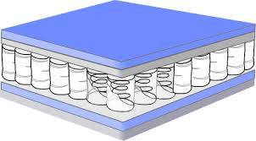Also called pocketed coils, this design features metal coils that are individually wrapped in fabric sleeves. This allows each coil to move independently from one another, which has the added effect of reducing noise. Pocketed coils are often used in higher-end beds, and are generally more expensive to make. They do a great job of providing targeted pressure relief, and tend to provide a more buoyant feel overall.

1. **Offset Coils –**

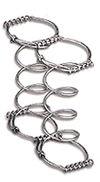Offset coils share some properties of pocket coils, but they are joined together with hinged wires. This allows the coils to flex under soft pressure, but provide firm support when it’s needed. Offset coils can provide more firmness than pocketed coils, so many innerspring beds with [higher firmness ratings](https://www.sleepfoundation.org/best-mattress/best-firm-mattress) over 7 out of 10 will use some form of offset coil. Beyond this application, offset coils are not commonly used.

The principal distinction of offset coils from Bonnells is the shape of the ends. The top and bottom ends of Bonnell coils are round. Then they are tied into rows by spiral wires. The ends of offset coils are squared at opposite ends. The squared ends of one coil are tied to those of the next coil with a helical wire. This functions as a hinge, which allows each coil to respond individually, making an offset coil [innerspring](https://beds.org/blog/spring-to-sleep/) unit more flexible than a Bonnell.

The flexibility of offset coils reduces pressure points on protruding parts of the body, such as shoulders and hips. This also means better back support, especially for side sleepers. Additionally, this reduces motion transfer. Alternating right-hand turning coils with left-handed ones makes the mattress more stable by countering any tendency to lean one direction or the other.

There are two basic forms of offset coils, knotted and un-knotted. Knotted ones are more stable and have a smoother feel. Un-knotted Karr coils are springier and more flexible.

1. **Continuous Coils –**

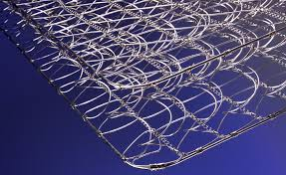Continuous coil design features a single wire that is used to construct an entire row of “coils”. Each of these rows is then attached to each other using helical wires. This design provides a very firm support system, but because each component is joined together, continuous coils have much less ability to shape themselves to a body profile.

Continuous coils are the least expensive type of [coils](https://beds.org/blog/spring-to-sleep/) used in [innerspring mattresses](http://www.beds.org/best-innerspring-mattress.php). According to [Seattle Mattress Company](http://www.seattlemattress.net/), this coil type was invented by [Serta](http://www.beds.org/manufacturer/serta.htm). Currently, Serta is the largest user of continuous coils. Serta‘s continuous coils are manufactured by [Leggett & Platt](http://www.beds.org/adjustablemanufacturer/leggett-and-platt.htm) under the trade name Miracoil. Continuous coils are among the five most commonly used [innerspring coil](https://beds.org/blog/spring-beds-the-good-the-bad-and-the-ugly/) systems. The other coil types are [Bonnell coils](https://beds.org/blog/bonnell-coils/), knotted and un-knotted [offset coils](https://beds.org/blog/offset-karr-coils/), and pocket (Marshall) coils (which also includes [micro-coils](https://beds.org/blog/microcoils/)).

Continuous coils are so-named because an entire row of coils is formed from one continuous wire. Each row is tied to the next row by a spiral (helical) wire. The wire forms one coil going up and the next going down, which means the coils are paired, the helical wire also links one end of a coil pair to the end of the next pair in the row. The benefits of continuous coils include affordability, durability, stability, and consistent support. They also enable greater coil density, which makes support smoother. As with other coil systems, the goal is to enable the users to experience [quality sleep](https://beds.org/blog/quality-sleep-how-to-get-a-night-of-rest-and-restoration/).

The principal drawback of continuous coils is that motion is transferred along the row. For this reason, coil rows usually run head-to-toe. The helical connection of one row to another acts like a hinge, providing more flexibility across the mattress to lessen motion transfer between sleeping partners. This also reduces the load carried by each individual coil.

Some mattress models have rows of continuous coils both lengthwise and crosswise. This significantly increases coil density, enabling the mattress to support more weight.

1. **Cotton Mattress**

Cotton is a soft, fluffy [staple](https://en.wikipedia.org/wiki/Staple_(textiles)) [fiber](https://en.wikipedia.org/wiki/Fiber) that grows in a [boll](https://en.wiktionary.org/wiki/boll), or protective case, around the seeds of the cotton plants of the genus [Gossypium](https://en.wikipedia.org/wiki/Gossypium) in the mallow family [Malvaceae](https://en.wikipedia.org/wiki/Malvaceae).

The fiber is almost pure [cellulose](https://en.wikipedia.org/wiki/Cellulose). Under natural conditions, the cotton bolls will increase the dispersal of the seeds.

The plant is a [shrub](https://en.wikipedia.org/wiki/Shrub) native to tropical and subtropical regions around the world, including the Americas, Africa, Egypt and India. The greatest diversity of wild cotton species is found in Mexico, followed by Australia and Africa. Cotton was independently domesticated in the Old and New Worlds.

The fiber is most often [spun](https://en.wikipedia.org/wiki/Spinning_(textiles)) into [yarn](https://en.wikipedia.org/wiki/Yarn) or thread and used to make a soft, [breathable](https://en.wikipedia.org/wiki/Breathable) [textile](https://en.wikipedia.org/wiki/Textile). The use of cotton for fabric is known to date to prehistoric times

**Cotton Types**

|  |
| --- |
| Cotton is the most widely used fibre for fabric because of its strength, durability and breathability. The word "staple" refers to fibre length. When someone refers to "long staple cotton" they are referring to variety 1, 2, or 3. The longer the fibre size of a variety, the more difficult it is to grow, and the more difficult it is to process. Hence the longer the staple, the more expensive it becomes.  The chart shows the approximate relative sizes of the fibres. |

* 1. **Sea Island cotton**

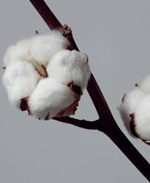

Sea Island cotton is in extremely limited supply, and is very expensive to grow and to process. It is typically used in very expensive men's shirts.

* 1. **Egyptian Cotton**

Egyptian cotton was developed from stocks that

Originated in South and Central America. Menoufi is the most widely used variety. The highly prized Giza variety has exceptionally strong fibres about 1 ½" long, and is used in the best qualities of embroidery thread, and the finest cotton fabrics for sheets and duvet ticking’s.

Genuine Egyptian cotton is very rare, at approximately 0.3% of the total cotton production worldwide. For this reason, most "Egyptian Cotton" is simply not Egyptian species cotton and is merely marketed with this label, or perhaps has a small percentage of Egyptian species blend. Our cotton is the real deal, 100% Giza 70.

* 1. **Pima Cotton**

Pima cotton is in between Egyptian cotton and American Upland long staple in length and price. It is a very good quality.

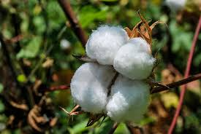

### **What is a Cotton Mattress?**

A cotton mattress is simply a bed mattress with cotton as the primary material. These mattresses have no organic

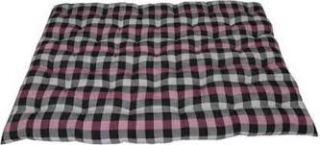

Addictive and simply pure nature. So, they are always recommended for a better comfortable piece. Even, kids can find a happy place here. The cotton mattress is available for both single and double beds. One can choose from the latest designs and different colours available in the market.

#### **Various Advantages of Cotton mattresses –**

Cotton mattresses are an extraordinary choice if comfort is the first and foremost point one considers. Since cotton mattresses are derivatives of natural products, they offer an extremely comfortable sleep to all users in all weather conditions.

#### **Disadvantages of Cotton mattresses** –

But the disadvantages are that cotton mattresses attract bugs and are unhygienic. Also, they were preferred for comfort but after a certain time, they lose their comfort level very fast. Moreover, the texture and the composition of the mattress become so hard and thin that the mattresses can’t stand vertically.

## Is Cotton Mattress Good For Health?

Cotton being a natural product is generally good for health. But it should be organic.

However as cotton mattresses tends to sag, it loses shape easily and becomes uneven. This causes back aches.

A cotton mattress also attracts dust mites and other germs, which can cause various diseases. A cotton mattress gets soiled and becomes dirty easily.

For all these reasons, a cotton mattress is not good for health at all. That is why research is always going on to develop a more healthy and comfortable mattress.

## Is Cotton Mattress Good For Back Pain?

You must have read above that cotton mattress is not good for back pain at all.

To repeat, cotton being a loose material, loses its shape after few years and becomes uneven.

Cotton is also non-responsive, meaning, it cannot adjust to the body curves. Hence a cotton mattress cannot provide proper spinal alignment when we toss and turn in bed.

So a cotton mattress is not good for providing relief from back pain.

White Cotton Bed Mattress, Thickness: 3 Inches

₹ 350/-

|  |  |
| --- | --- |
| Brand | Maratha Mattress |
| Thickness | 3 inches |
| Type | Cotton |
| Colour | White |
| Material | Cotton |